
Module Code & Module Title
CP70017E Dissertation
Assessment Weightage & Type
100% Individual Coursework
Student Name:
College ID:
Assignment Due Date: 5th June 2026
Assignment Submission Date: 5th June 2026
ARES PdM: A Digital-Twin Framework for Predictive Maintenance of Tactical Unmanned Aerial Vehicles using Deep Learning and Explainable Artificial Intelligence
Declaration
I declare that this dissertation is the result of my own work. Where the work of others has been used or referenced, this is acknowledged in accordance with the University's regulations on academic conduct. No part of this submission has previously been submitted for any other academic award.
Signed: ____________________ Date: ____________________

Acknowledgements
I would like to thank my supervisor for their patient direction throughout this project, the staff of the School of Computing for the hardware and software infrastructure made available during the practical phase, and my family for their continued support during the writing of this dissertation.

Abstract
Tactical Unmanned Vehicles (UAVs) are increasingly being used in real time, time-critical surveillance, logistics and defense operations but the maintenance remains dominated by fixed interval inspections rather than the UAVs actual real-time condition. This dissertation presents ARES PdM (Aerial Reliability and Endurance System for Predictive Maintenance), a digital-twin framework that couples a deep-learning prognostics pipeline to a real-time tactical heads-up display, with the objective of providing operators with traceable, condition-based maintenance guidance for a heterogeneous UAV fleet.
Three deep learning architectures have been used; a stacked Long Short-Term Memory (LSTM) network, a four-block one-dimensional Convolutional Neural Network (CNN) and a Transformer Encoder. These models are trained for prediction of Remaining Useful Life (RUL) on two datasets, the publicly available NASA Commercial Modular Aero-Propulsion System Simulation (C-MAPSS) turbofan benchmark used as an external validity anchor and data generated from a procedurally generated multirotor UAV fleet consisting of 20 airframes which was flown over 10 flights each, across four health conditions: healthy operation, bearing wear, ESC thermal faults, and battery degradation. In the UAV branch, each model is trained to perform two tasks at the same time: predicting remaining useful life (RUL) and classifying faults into one of four categories. The predictions are made easier to understand using Transformer attention visualisations and Integrated Gradients to show which sensors are most important. Both are displayed directly in a Next.js operator dashboard. A FastAPI inference service streams synthetic UAV telemetry from a server-side flight generator through WebSockets, creating a complete digital-twin pipeline that connects simulated flight physics, trained models, and operator decision-making.
On the C-MAPSS benchmark dataset, which includes a combined test set of 707 engines from FD001–FD004, the Transformer model achieved the best performance with an RMSE of 16.40 cycles and a NASA Score of 4,074. The LSTM model followed closely with an RMSE of 16.47 and a NASA Score of 4,224, while the 1D-CNN achieved an RMSE of 18.49 and a NASA Score of 6,516.

For the synthetic UAV fleet dataset containing 85,292 validation windows, the Transformer again produced the strongest results, achieving an RMSE of 3.45 flight-hours and a fault-classification accuracy of 95.5%. The 1D-CNN achieved a lower predictive performance with an RMSE of 4.08 and a fault accuracy of 61.5%, while the LSTM achieved an RMSE of 4.75 with a fault accuracy of 88.0%.
This work makes three main contributions. First, it provides an open and reproducible pipeline that combines the turbofan benchmark and a synthetic UAV fleet within a single training framework. Second, it introduces an explainability layer that presents attention maps and Integrated Gradients sensor attributions directly within an operational dashboard. Third, it proposes an architectural approach where a single static-artifact contract supports both reliable offline reproducibility and real-time inference deployment.

Table of Contents
Introduction 8
Context and Motivation 8
Aim and Research Question 9
Research Question 9
Objectives 9
Scope and Delimitations 10
Contributions 11
Dissertation Structure 11
Background 13
From Reactive to Predictive Maintenance 13
Run to Failure Data and the C-MAPPS Benchmark 14
Tactical UAV Health Monitoring 15
Deep Sequence Models for RUL Estimation 16
Digital Twins 17
Explainable Artificial Intelligence in PHM 18
Summary 19
Literature Review 20
Predictive Maintenance in Aviation: From Practice to Data-Driven Models 20
Data Driven RUL on C-MAPSS 21
UAV Specific Prognostics Study 22
Digital Twins for Aviation Predictive Maintenance 24
Explainability as Regulatory and Operational Necessity 25
Synthesis 26
Methodology 27
Datasets 27
Nasa C-MAPPS 27
Synthesized UAV Fleet 28
Reproducibility 30
Model Architectures 31
LSTM 31
1D-CNN 31
Transformer Encoder 32
Training Protocol 32
Explainability Extraction 33
Attention 33
Integrated Gradients 34
Live Inference Pipeline 34
Evaluation Methodology 35
System Design and Implementation 37
Repository Layout and Conventions 37
Static Artifact Contract 37
The Dashboard 38
The Inference Backend 40
The two modes of the Mission View 40
Reproducibility and Deployment Notes 41
Results and Evaluation 41
Quantitative Results C-MAPSS 42
Quantitative Results: Synthesized UAV Fleets 43
The Two Datasets in Comparison 44
Qualitative Results Dashboard Surfaces 44
Live Inference 45
Summary 45
Discussion 46
Why the Transformer Wins 46
The END_OF_THE_LIFE_HOURS Calibration 47
Generalization Gap 48
Operational Implications 48
Threats to Validity 49
Reflections on the Process 49
Conclusion and Future Work 50
Conclusions 50
Future Work 51
References 53

List of Tables
Table 1: C-MAPSS Headline Results (combined test set, n=707) 43
Table 2: Synthesized UAV Headline Results (Validation Set, n=85292 windows) 44

Introduction

Context and Motivation
In operational terms, maintenance represents the largest contributor to the through-life cost of an aerial platform. In the case of tactical unmanned aerial vehicles (UAVs), this cost burden is further intensified by two interrelated factors. First, the airframes are typically inexpensive relative to the value of the onboard payloads, operator training requirements, and the mission losses incurred when a system becomes unavailable due to grounding. Second, the operational demands placed on tactical UAVs including rapid deployment, short turnaround times, and frequent reconfiguration make traditional fixed-interval inspection schedules less effective. Maintenance plans developed for stable training environments cannot be directly applied to contested operational conditions.
Condition-Based Maintenance Plus (CBM+) and the wider field of Prognostics and Health Management (PHM) suggest that sensor data collected during normal system operation can be used to replace or support traditional time-based inspection methods. Unlike reactive maintenance, which responds to failures after they occur, and preventive maintenance, which follows fixed maintenance schedules, predictive maintenance uses data-driven approaches to estimate the Remaining Useful Life (RUL) of components or systems. Maintenance actions are then planned only when the predicted RUL reaches a level that requires intervention. The potential benefits are substantial, including fewer unexpected component removals, a longer operational lifespan for each airframe, and earlier detection of possible catastrophic failures. However, achieving these benefits depends on several key factors; access to reliable run-to-failure data, the development of models capable of identifying degradation patterns from that data, and an effective system for presenting these predictions to operators in a clear and actionable way.
Over the last decade, deep learning has significantly advanced, especially through recurrent and attention-based architectures that can effectively capture long-range temporal patterns in multivariate data. This progress has encouraged the prognostics research community to increasingly adopt data-driven approaches for Remaining Useful Life (RUL) estimation. However, two persistent gaps remain. The first concerns credibility: if a model predicts that a fleet will be grounded within three days, operators are unlikely to trust this output unless they can examine the reasoning behind it. The second concerns operational realism: a model whose only evidence of performance is an offline RMSE score on a benchmark dataset has not yet shown that it can support a real decision in a live, streaming environment.
This dissertation addresses both gaps in the context of a tactical UAV digital twin.

Aim and Research Question
To design, develop, and assess a digital-twin framework that provides clear and explainable predictive-maintenance support for a tactical UAV fleet. The framework uses deep-learning techniques to analyze different types of run-to-failure data and delivers condition-based maintenance predictions through an operator dashboard.

Research Question
Can a single and reproducible deep-learning framework accurately predict the Remaining Useful Life (RUL) of both a well-known turbofan benchmark system and a synthetic UAV fleet, while also providing clear explanations of its predictions through attention and gradient-based interpretation methods that are useful for operator decision-making?

Objectives
- To develop a unified data-processing pipeline that integrates the NASA C-MAPSS turbofan benchmark dataset with a procedurally generated multirotor UAV fleet dataset, using consistent methods for data windowing, normalization, and Remaining Useful Life (RUL) target generation.
- To implement and train three deep-learning architectures - LSTM, 1D-CNN, and Transformer Encoder within a unified configuration-based training framework, resulting in a total of six trained models across the selected datasets.
- To generate two explainability outputs self-attention maps and Integrated Gradients sensor attributions and package them into a per-asset payload for the dashboard.
- To implement a FastAPI inference service that streams synthetic UAV telemetry and live RUL/fault predictions over a WebSocket protocol.
- To implement a Next.js operator dashboard with four functional views (Armory, Mission, Diagnostics, and Lab), unifying offline replay and live inference within a single state model.
- To evaluate the framework quantitatively (RMSE, NASA Score, classification accuracy, training time) and qualitatively (interpretability of XAI outputs).

Scope and Delimitations
The project scope is intentionally kept focused. The UAV fleet is simulated rather than physically flown because there is currently no publicly available run-to-failure dataset for tactical-class multirotor drones with the level of detail needed for supervised Remaining Useful Life (RUL) prediction. Collecting this kind of real-world data is also beyond the time and resource limits of an MSc project.
For this reason, the C-MAPSS dataset is used as a benchmark to validate the approach. If the proposed pipeline can achieve results comparable to published studies on a widely recognized dataset, it increases confidence in applying the same methodology to the simulated UAV fleet.
The dashboard is intentionally limited to twelve assets; eight turbofan engines and four quadrotors; to keep the 3D carousel and individual diagnostic views clear and easy to interpret. Broader production-level features such as user authentication, multi-tenant deployment, and network security are acknowledged but are outside the scope of this project.

Contributions
The main contributions of this dissertation are as follows:
- It introduces a fully reproducible training pipeline that brings together both the C-MAPSS turbofan dataset and a procedurally generated UAV fleet within a single workflow. Using a unified driver, the system consistently produces six trained models that follow a stable and reusable artifact structure.
- It presents a digital-twin operator interface where explainability is treated as a core feature rather than an afterthought. Transformer attention maps and Integrated Gradients attributions are directly integrated into the interface, allowing operators to interpret model behaviour in a more intuitive and transparent way.
- It develops a two-layer serving architecture that separates offline replay analysis from real-time streaming inference while maintaining a shared per-asset JSON schema. This design enables the same dashboard components to function seamlessly in both operating modes without requiring separate code paths.
- It provides a detailed quantitative evaluation of LSTM, 1D-CNN, and Transformer models across two domains: the C-MAPSS turbofan benchmark and a UAV-based task involving both regression and classification objectives.

Dissertation Structure
Chapter 2 provides the technical foundation for the study, covering Prognostics and Health Management (PHM), deep sequence learning models, digital twins, and explainable AI.
Chapter 3 then explores the most relevant literature, grouping previous work by theme and highlighting the research gap that the ARES PdM framework is designed to address.
Chapter 4 explains the methodology in detail, including the datasets used, preprocessing steps, model architectures, training procedures, and the process for generating explainability outputs.

Chapter 5 focuses on the design and implementation of the system, describing both the inference backend and the operator-facing dashboard.
Chapter 6 presents the evaluation results through both quantitative metrics and qualitative analysis.
Chapter 7 interprets these findings, discussing their practical implications, potential threats to validity, and how the results can be understood in an operational context
Finally, Chapter 8 summarises the overall work and outlines possible directions for future research and development.

Background
This chapter lays the conceptual and technical groundwork for the rest of the dissertation. It is written for readers who have a background in software engineering and basic machine learning, but who may not be familiar with prognostics research.

From Reactive to Predictive Maintenance
Maintenance strategies are usually grouped based on how far ahead they try to anticipate failures.
Reactive (or corrective) maintenance only takes place after a fault has already occurred. While this approach reduces planned maintenance time, it often leads to unexpected downtime and carries the highest risk and cost if a failure happens during operation.
Preventive maintenance, in contrast, is performed at fixed time intervals or after a certain amount of usage, using schedules based on general statistics across many systems. This lowers the likelihood of sudden failures, but it is often overly cautious because the schedule is designed for the most worn or degraded equipment. As a result, many systems are serviced earlier than necessary.
Predictive maintenance (PdM), also known in the U.S. military as Condition-Based Maintenance Plus (CBM+), makes maintenance decisions based on the current condition of a specific asset and predictions about its future health. It is based on three main ideas:
- Important system degradation creates noticeable signs in the available sensor data.
- These signs can be modelled accurately enough to support decision-making;
- the resulting decision can be provided to the operator quickly enough to still be useful and actionable.
The output of a predictive maintenance system is commonly represented in one of two forms: a health index or a Remaining Useful Life (RUL) estimate. A health index is a scalar value within a bounded range that reflects the current condition of a system, where decreasing values indicate progressive degradation. In contrast, RUL estimates predict the amount of operating time, cycles, or flights remaining before the system reaches a predefined failure threshold. Although RUL is generally more useful for operational planning because it is expressed in practical units familiar to operators, it is also more challenging to estimate accurately since it requires forecasting future system behavior rather than assessing only the current condition.

Run to Failure Data and the C-MAPPS Benchmark
Supervised RUL estimation relies on run-to-failure data; operational trajectories that start in a healthy state, progress through one or more degradation stages, and end at a clearly defined failure point. However, such data is rarely available publicly because operators of high-value aerial platforms generally do not intentionally run their assets to failure under controlled conditions. A key exception is the NASA Commercial Modular Aero-Propulsion System Simulation (C-MAPSS) dataset, which contains four subsets, FD001 to FD004, representing simulated turbofan engine degradation scenarios. These subsets differ in complexity, from a single operating condition with one fault type in FD001 to six operating conditions with two combined fault types in FD004. Each engine record includes multivariate time-series data collected from 21 sensor measurements and three operational settings, with the sequence ending once the engine reaches a predefined failure threshold.
C-MAPSS is widely recognized as the standard benchmark for data-driven Remaining Useful Life (RUL) estimation. Its simplified structure characterized by discrete operating cycles, complete data without missing values, and a fixed set of sensor measurements makes the dataset highly accessible for research and model development. However, this simplicity can also encourage models to overfit to the dataset’s specific characteristics rather than generalize effectively to real-world scenarios. A commonly adopted approach is to use a piecewise-linear RUL target function, typically capped at 125 cycles (Heimes, 2008). This convention assumes that the true RUL during the early stages of engine operation is highly uncertain, and therefore models should not be heavily penalized for inaccurate predictions in that phase.
The most used evaluation metrics are Root Mean Square Error (RMSE), which treats prediction errors symmetrically, and the NASA Score, which applies a greater penalty to late predictions that overestimate the remaining useful life compared to early predictions that underestimate it. This asymmetric scoring reflects practical safety considerations, as an early warning allows maintenance to be scheduled in advance, whereas a delayed warning increases the risk of in-service failure.

Tactical UAV Health Monitoring
Tactical UAVs differ fundamentally from turbofan engines in ways that are highly consequential for prognostics. Although UAVs are equipped with dense sensor networks, these systems are primarily designed to support flight control rather than health or condition monitoring. Their principal degradation mechanisms also differ substantially, encompassing battery capacity degradation, wear in motors and electronic speed controllers (ESCs), propeller and bearing imbalance, and thermal stress events. In addition, UAV operational profiles are typically short-duration and highly variable, lacking a direct equivalent to the well-defined operating “cycles” commonly used in turbofan prognostics. The associated safety framework is likewise distinct: instead of relying on a single end-of-life criterion, UAV reliability is determined by multiple fault thresholds, where the violation of any one threshold may render a mission unsafe or infeasible.
Public run-to-failure datasets for tactical UAV prognostics remain limited. Among the few available resources, the ALFA fixed-wing fault-flight dataset and several NASA-inspired multirotor testbeds reported in recent studies provide the closest points of comparison. However, their fault classifications, sensor configurations, and operating assumptions differ significantly from the tactical multirotor context examined in this dissertation. To address this gap, the approach adopted in this work is to generate a synthetic fleet using a transparent and well-documented procedural modelling framework that reproduces the key degradation behaviors of interest. At the same time, the established C-MAPSS dataset is retained as an external benchmark to support the validity and comparability of the modelling pipeline.

Deep Sequence Models for RUL Estimation
Three families of deep-learning architectures dominate the RUL literature, and all three are evaluated in this dissertation.
Long Short-Term Memory (LSTM) networks are a class of recurrent neural architectures designed to preserve information over extended input sequences through a gated cell-state mechanism, thereby alleviating the vanishing-gradient problem commonly encountered in standard recurrent neural networks (RNNs). During the mid-2010s, LSTMs became the predominant approach for sequence modelling and continue to serve as a strong baseline for Remaining Useful Life (RUL) prediction tasks. Their effectiveness in this domain stems from the alignment between the recurrent inductive bias of LSTMs and the nature of RUL estimation, which involves identifying gradual degradation patterns within long, noisy, and multivariate time-series data.
A one-dimensional Convolutional Neural Network (1D-CNN) models multivariate time-series data as a one-dimensional signal, where each sensor represents an individual input channel. By applying stacked convolutional layers, the network can automatically learn and extract local temporal features from the data. Compared with recurrent architectures, CNNs are generally more parameter-efficient and highly parallelizable on GPUs, enabling faster training and inference. They are particularly effective in scenarios where degradation signatures manifest as localized temporal patterns such as vibration spikes or thermal anomalies rather than long-range sequential dependencies.
The Transformer encoder, first introduced in natural language processing and later adopted across different modalities, removes the need for recurrent structures entirely. Instead, each timestep can attend to all other timesteps through a learned multi-head self-attention mechanism. This allows the model to capture long-range dependencies more effectively, without forcing information to pass through a sequential bottleneck. Importantly for this dissertation, the resulting attention matrix also provides an interpretable representation of how the model processes information. However, this comes at the cost of quadratic memory complexity with respect to sequence length, which limits the size of the practical lookback window.

Digital Twins
A digital twin can broadly be defined as a computational representation of a physical asset that remains continuously synchronized with the real system through streams of sensor data. In addition to mirroring the condition of the asset, the digital twin can provide predictive and prescriptive insights to support operational decision-making. The concept originally emerged within product lifecycle management but has since expanded into sectors such as aerospace, energy, and manufacturing.
Within aviation predictive maintenance, the digital twin is increasingly viewed as an integration layer that connects heterogeneous data sources, including telemetry streams, maintenance records, and design specifications, with the AI models responsible for analysis and prediction. Recent studies in aviation digital-twin research highlight that real-time prognostic systems are difficult to support using fully centralised cloud architectures alone. This is largely due to the extremely large data volumes generated by modern aircraft systems; for example, a twin-engine commercial aircraft may produce approximately twenty terabytes of data per engine per hour. In addition, predictive maintenance applications often require low-latency processing to enable timely decision-making.
As a result, many researchers advocate for an edge–fog–cloud architecture, where data processing and inference are performed as close to the physical asset as possible, while larger-scale storage and long-term analytics remain in the cloud. This architectural consideration directly motivates the FastAPI-on-localhost serving approach adopted in this dissertation, as it enables low-latency inference and more efficient handling of high-frequency sensor data.

Explainable Artificial Intelligence in PHM
A predictive-maintenance system whose outputs cannot be interrogated is unlikely to gain user trust and, in regulated domains, may not be approved for deployment. Explainable Artificial Intelligence (XAI) addresses this issue by providing techniques that reveal the reasoning behind a model’s predictions. This dissertation employs two classes of XAI techniques.
Attention visualization takes advantage of the Transformer encoder’s self-attention mechanism, which acts as a soft alignment across input timesteps. The attention matrix can be directly extracted from the trained model and displayed as a heatmap, allowing the researcher to observe which previous timesteps the model considered most important when generating a prediction at a specific point in time. Although attention weights should be interpreted cautiously, as they are not a definitive measure of feature importance, they still provide valuable insight into the model’s decision-making process. In this application, where the alternative would be a completely opaque scalar output, the attention map offers a meaningful improvement in the interpretability and auditability of the model.
Integrated Gradients (IG) is a gradient-based attribution technique used to explain how individual input features influence a model’s prediction. The method works by calculating the gradients of the model’s output with respect to the input features along a straight-line path between a baseline input and the actual input. By integrating these gradients, IG produces attribution scores that indicate the contribution of each feature to the final prediction. Unlike standard saliency methods, Integrated Gradients is less affected by gradient saturation and satisfies the completeness property, meaning that the total feature attributions correspond to the difference between the baseline prediction and the actual prediction. In this study, IG is applied across the lookback window to generate a per-sensor importance vector, which is displayed in the dashboard as a bar chart alongside the wireframe visualization to improve model interpretability.

Summary
This chapter has demonstrated that predictive maintenance for tactical UAVs involves estimating Remaining Useful Life (RUL) from multivariate time-series data, often in situations where run-to-failure data is limited. It has also shown that deep learning sequence models, including LSTMs, 1D-CNNs, and Transformers, are widely used approaches for performing this estimation. Furthermore, the chapter highlighted how digital twins and edge-based inference provide the architectural framework required to deploy these models in operational environments. Finally, it established that explainability is a critical requirement for building operational trust in predictive maintenance systems, rather than simply an optional feature. The following chapter explores these concepts further through a review of recent peer-reviewed literature.

Literature Review
This chapter critically reviews the literature relevant to ARES predictive maintenance (PdM) across five key thematic areas: conventional and emerging predictive-maintenance approaches; data-driven remaining useful life (RUL) estimation using the C-MAPSS dataset; UAV-specific prognostic methodologies; digital-twin frameworks within the aviation sector; and explainability as both an operational and regulatory requirement. Each subsection concludes by identifying the specific research gap that this dissertation seeks to address.

Predictive Maintenance in Aviation: From Practice to Data-Driven Models
The transition from preventive to predictive maintenance in aviation has occurred progressively, shaped largely by the regulatory conservatism that characterises the sector. Costa et al. (2026), through a PRISMA-based systematic review of twenty studies published between 2017 and 2025, identify hybrid CNN–RNN deep-learning architectures as the predominant approach for prognostic applications. However, the review also highlights four enduring barriers to widespread implementation: the limited explainability of model outputs, challenges associated with the regulatory certification of AI-based systems, heterogeneity in data sources across operator fleets, and the difficulty of scaling experimental models from individual airframes to fleet-wide deployment. Furthermore, the authors note that the existing body of literature is heavily concentrated on civil aviation, largely due to the availability of open datasets and established certification frameworks, whereas military and tactical aviation contexts which are of primary relevance to this dissertation remain comparatively underrepresented because of restrictions surrounding operational data publication.
The implications for the present study are twofold. First, the adoption of a hybrid methodological framework integrating a deep-learning model zoo with explicit explainability mechanisms is consistent with the prevailing direction identified within the literature. Second, the limited representation of tactical-class platforms in existing research provides methodological justification for the development of a synthesized UAV fleet dataset, provided that the processes underlying its construction and validation are documented with sufficient transparency and rigor.

Data Driven RUL on C-MAPSS
Since its release, the C-MAPSS dataset has generated a substantial body of research on prognostics and remaining useful life (RUL) estimation. Early studies primarily relied on manually engineered statistical and spectral features, such as kurtosis, skewness, and spectral moments, which were subsequently used as inputs to shallow regression models. Later research shifted toward deep learning approaches, particularly Long Short-Term Memory (LSTM) and bidirectional LSTM architectures, enabling models to learn temporal degradation patterns directly from windowed multivariate sensor data. More recently, the field has been increasingly dominated by attention-based and Transformer-oriented architectures, often integrated with convolutional front-end layers to enhance feature extraction and sequence modelling capabilities.
Performance on the benchmark has improved considerably over time. For example, reported Root Mean Square Error (RMSE) values on the comparatively simple FD001 subset have decreased from more than twenty cycles in earlier studies to values in the low teens in recent state-of-the-art approaches, with similar trends observed across the more complex subsets. In contrast, the NASA Scoring Function demonstrates substantially greater variability because of its asymmetric penalty structure, making it particularly sensitive to delayed predictions, especially for engines exhibiting long degradation trajectories.
Two methodological considerations consistently emerge throughout the literature and directly inform the design choices adopted in this dissertation. First, Remaining Useful Life (RUL) clipping through a piecewise-linear target formulation is almost universally implemented using a clipping threshold of 125 cycles; deviations from this convention reduce comparability across studies and are therefore not adopted here to maintain consistency with prior work. Second, many state-of-the-art results depend heavily on ensemble techniques and extensive per-subset hyperparameter optimisation, often requiring highly specific training configurations that are difficult to reproduce reliably. Consequently, this dissertation prioritises transparency and reproducibility by reporting results obtained using a single training pipeline, a unified configuration, and a single random seed across all experiments. Although this approach may limit peak benchmark performance, it provides a more consistent and reproducible framework for evaluation and comparison.
The gap addressed is the lack of a unified Transformer-based RUL pipeline evaluated consistently across domains. This work presents a Transformer-based approach for C-MAPSS and reports results alongside a UAV-class dataset using the same training driver, enabling a controlled cross-domain comparison rather than limiting evaluation to a single-domain benchmark.

UAV Specific Prognostics Study
The literature focused specifically on UAV applications is comparatively recent and remains fragmented. A notable contribution by Ozkat et al., published in the “International Journal of Micro Air Vehicles”, presents a vibration-based Remaining Useful Life (RUL) estimation framework for a DJI M600 multirotor equipped with a grooved propeller blade. Their methodology samples IMU data at 800 Hz, applies moving-median and bandpass filtering, generates spectrograms, and extracts a mean peak-frequency feature for analysis. A two-layer LSTM network comprising 100 and 50 cells respectively, with a dropout rate of 0.2, is then trained to predict five future values using the previous seven observations as input.
The authors report RMSE values ranging from 1.35 to 3.71 Hz across three experimental replications, with a maximum prediction horizon of ten seconds. In their study, the healthy operating condition corresponds to a fundamental frequency of approximately 40 Hz, while a mean peak frequency of 50 Hz is defined as the failure threshold.
This work represents the closest comparable study to the LSTM-based component of the present research and directly informs several methodological decisions. Specifically, it supports the use of vibration data as a primary predictive input, reflected in the synthesized UAV dataset through per-motor vibration RMS measurements. It also justifies the inclusion of LSTM networks as one of the three baseline architectures evaluated in this study, as well as the adoption of a rolling-window forecasting framework for forward prediction.
Bondyra et al. (2022), writing in the journal *Drones*, propose CompactNeuroUAV, an architecture that combines a convolutional feature-compaction front-end with a bidirectional GRU (BiGRU) temporal encoder. The model is evaluated using the ALFA dataset, which contains fixed-wing fault-flight scenarios involving a Carbon Z T-28 aircraft with simulated faults including engine shutdown, elevator-stuck, rudder full-deflection, and aileron-stuck conditions. The architecture generates three outputs: per-parameter deviation, set-of-parameter deviation, and fault-class probability. The authors also highlight the requirement for an onboard neural processing unit to satisfy real-time edge-computing latency constraints.
This study represents the closest comparable architecture to the Transformer-based branch of the present work. However, the current dissertation differs in three key respects: a Transformer encoder is adopted in place of the BiGRU to improve attention interpretability and auditability; the model retains both a regression output for RUL prediction and a classification output for fault identification; and the target platform is a multirotor UAV rather than a fixed-wing aircraft.
Darrah et al., in their PHM 2021 study on a UAV simulation testbed, describe a PostgreSQL-backed Simulink framework used to monitor forty-four run-to-failure UAVs over a total of 3,624 flights. The study identifies battery internal-resistance growth as the primary failure mechanism, with degradation reaching approximately 1,000% over the operational lifetime of the assets and safety-threshold violations typically occurring around the eightieth flight. In addition, the proposed data-management framework emphasizes reproducibility, explainability, extensibility, and maintainability as core design principles. The synthesized UAV fleet developed in the present dissertation is conceptually derived from this framework; however, it is implemented at a smaller scale, comprising twenty airframes with ten flights each, in line with the resource constraints of an MSc project.
A complementary perspective is provided by Sai et al. (2023, IEEE), whose survey situates UAV predictive maintenance within a broader AI-for-UAVs framework encompassing applications such as path planning, flight control, networking, object detection, collision avoidance, and swarm intelligence. The authors identify two dominant data-driven predictive maintenance approaches in the existing literature: IMU-based vibration analysis and LSTM-based anomaly detection trained exclusively on healthy operating data. The survey also highlights the emerging application of reinforcement-learning controllers for motor thermal management, aimed at mitigating degradation before critical failure occurs.
In a related contribution, Al-Darraji et al. (2021) present an engineering-oriented taxonomy of UAV navigation sensors structured according to Levels of Autonomy. Within the context of the present dissertation, this taxonomy is primarily valuable for informing and validating the sensor-channel classification adopted for the synthesized UAV fleet.
The research gap addressed in this dissertation arises from the limited scope of existing UAV predictive maintenance studies. Previous work has typically focused either on evaluating a single model architecture using a bespoke UAV dataset, as demonstrated by Ozkat, or on applying a single architecture to a publicly available fault-flight dataset, as in the work of Bondyra. To the author’s knowledge, no prior study has presented a controlled comparative evaluation of three distinct architectures on a UAV-focused dataset while simultaneously benchmarking performance against C-MAPSS results generated using the same training pipeline and experimental framework.

Digital Twins for Aviation Predictive Maintenance
Mehdipour et al. (2026) presented a PRISMA-ScR scoping review of eighty-three digital twin studies in aviation, and several findings are directly relevant to the architectural design of this dissertation. First, the review classifies digital-twin data into three main categories: time-series, graphical, and natural-language data. The authors argue that multi-model databases are better suited to managing this diverse data than purely relational or NoSQL systems. Second, the study highlights the large scale of data involved in real-time aviation twins, noting that a modern twin-engine commercial aircraft can generate around twenty terabytes of data per engine every hour. Third, the authors recommend a three-layer edge–fog–cloud architecture for real-time digital-twin inference because fully centralized cloud systems cannot satisfy the low-latency requirements of safety-critical aviation applications. In this dissertation, the FastAPI-on-localhost deployment approach represents an implementation of the edge layer within this architecture.
A key gap identified in the existing literature is that most aviation digital-twin studies focus either on high-level architectural concepts or on the underlying data-management systems. Fewer studies provide a complete end-to-end implementation that integrates a deep-learning prognostic model with edge-based deployment and a live operator dashboard in a reproducible open-source framework. This dissertation aims to address that gap by demonstrating such an implementation in practice.

Explainability as Regulatory and Operational Necessity
Costa et al. (2026) and Mehdipour et al. (2026) both argue that explainability is not merely a desirable enhancement to machine learning systems, but a fundamental prerequisite for their adoption in safety-critical domains. This distinction is particularly significant within aviation, where regulatory authorities must certify and approve any model deployed in operational service. In such a context, the inability to provide a transparent and interpretable explanation for a model’s prediction represents not simply a technical limitation, but a direct barrier to certification and implementation.
Techniques such as Integrated Gradients, introduced by Sundararajan et al. in their 2017 ICML paper, together with developments in the wider attention-visualization literature, offer methodological approaches for improving interpretability. However, the key operational challenge is not solely the existence of these techniques, but whether they can be meaningfully integrated into the workflows of operators and decision-makers, rather than remaining isolated as post-hoc analytical tools. Addressing this challenge from the perspective of dashboard integration and user interaction forms the central focus of the present dissertation.
A complementary line of research is represented by the physics-informed approach proposed by Duan et al. (2026) in Batteries, where thermodynamic and fluid-dynamic residuals are incorporated into the deep-learning loss function for UAV lithium-ion battery Remaining Useful Life (RUL) prediction. Their study reports performance improvements over SVM, LSTM, and GAN-based baselines across varying operational conditions, including temperature ranges, C-rates, humidity levels, and wind speeds.
While the present dissertation does not implement a fully physics-informed loss function, it does incorporate a procedural battery model within the synthesized UAV fleet environment. In this model, voltage sag is influenced by internal resistance, current draw, and state of charge, reflecting the physical relationships highlighted in the work of Duan et al.
The research gap addressed by this dissertation lies not in the development of new explainability techniques themselves, but in their operational integration. Existing XAI research within predictive maintenance (PdM) is frequently presented as a separate analytical component, detached from the primary user interface. By contrast, this dissertation integrates attention maps and Integrated Gradients attributions directly into the operator-facing dashboard as central visual elements, rather than treating them as secondary or post-hoc diagnostic outputs.

Synthesis
Across the five thematic groupings, four key observations underpin the contribution of this dissertation. First, hybrid deep learning approaches have become the dominant framework for data-driven prognostics in aviation, although attention-based Transformer models remain less explored compared to LSTM and CNN-RNN architectures. Second, the limited availability of public UAV run-to-failure datasets presents a significant challenge, making the use of procedurally documented synthetic data generation a justifiable methodological approach. Third, real-time digital twin inference requires low-latency processing, which makes an edge-based deployment architecture more suitable than fully cloud-dependent solutions. Finally, explainability is essential for predictive maintenance systems, particularly in safety-critical aviation environments where transparent and interpretable decision-making is required. ARES PdM is therefore positioned at the intersection of these four research observations.

Methodology
This chapter describes the datasets, models, training procedures, and explainability methods used throughout this dissertation. The aim is to ensure that the study can be fully reproduced. With access to the source repository and an Apple Silicon machine, a reader should be able to replicate the main results presented in Chapter 6 simply by running make phase1.
To guarantee consistent and repeatable outcomes, all sources of randomness including fleet generation, mini-batch shuffling, and model weight initialization are controlled using a fixed random seed of 1,337. This seed is defined centrally in ml/config.py and is applied across the entire experimental pipeline.

Datasets

Nasa C-MAPPS
The C-MAPSS dataset consists of four subsets (FD001-FD004), each providing training trajectories that run until engine failure and test trajectories that are truncated at randomly selected points before failure. For each test trajectory, the corresponding true Remaining Useful Life (RUL) value is provided. Every trajectory includes 21 sensor measurements, covering variables such as temperatures, pressures, rotational speeds, fuel flow, and bleed air quantities, along with three operational setting variables. The complexity of the subsets varies according to the number of operating conditions and fault modes. FD001 represents the simplest scenario, containing a single operating condition and a single fault mode, whereas FD004 is the most challenging, featuring six operating conditions and two concurrent fault modes. Across all four subsets, the test set comprises 707 engines. After preprocessing and applying a sliding-window approach, the combined training dataset contains 125,819 samples.

Subset | Op. conditions | Fault modes | Train engines | Test engines
FD001 | 1 | 1 | 100 | 100
FD002 | 6 | 1 | 260 | 259
FD003 | 1 | 2 | 100 | 100
FD004 | 6 | 2 | 249 | 248
Combined | — | — | 709 | 707
Table 1: C-MAPSS Composition
The dataset is automatically downloaded using the fetch_cmapss.py script, which retrieves the data from the primary repository and, if necessary, falls back to a GitHub mirror. The download process is idempotent, meaning that rerunning the script does not modify an existing local copy of the dataset. A consistent preprocessing pipeline is applied to all four C-MAPSS subsets. First, each subset undergoes z-score normalisation. Sensor channels that remain constant throughout the dataset are then removed, leaving 14 informative sensors (indices 2, 3, 4, 7, 8, 9, 11, 12, 13, 14, 15, 17, 20, and 21 according to the original C-MAPSS numbering), following the standard practice adopted in previous studies. The Remaining Useful Life (RUL) target is calculated as the number of cycles remaining until engine failure for each time step and is capped at 125 cycles, as proposed by Heimes (2008). Finally, a sliding-window approach is used to generate training samples, where windows of 30 consecutive cycles are extracted with a stride of one cycle. This results in input tensors of shape (30, 14), representing 30-time steps and 14 sensor measurements for each training instance. Each sensor channel is standardised within its operating-condition cluster c using a z-score transform:
$$\overset{˜}{x}=\frac{x-μ_{c}}{σ_{c}}$$
Equation 1: z score normalization

The regression target is the piecewise-linear RUL of Heimes (2008), capped at 125 cycles:
$$R\left(t\right)=\min\left(125, t_{fail}-t\right)$$
Equation 2: C-MAPSS RUL Target

Each input is a sliding window of T consecutive steps over F channels (shape T×F), labelled by the RUL at its final step:
$$X_{i}=\left[x_{t-T+1},…,x_{t}\right], y_{i}=R\left(t\right)$$
Equation 3: Sliding Window

Synthesized UAV Fleet
The UAV fleet used in this study is generated using the ml/data/uav_synth.py script. The dataset consists of 20 simulated UAVs, with each UAV completing 10 missions. Mission durations are randomly sampled from a uniform distribution ranging from 800 to 1,300 seconds, corresponding to approximately 13–22 minutes of flight time.
At the start of the simulation, each UAV is assigned to one of four health conditions: healthy, bearing wear, ESC thermal fault, or battery degradation. These conditions are allocated according to predefined probabilities of 25%, 30%, 25%, and 20%, respectively. For UAVs assigned a fault condition, one of the four motors is randomly selected during each flight as the location where the fault is introduced.
The procedural flight simulator generates 22 sensor channels at each timestep, sampled at a frequency of 10 Hz, alongside a mission-time index (t) and a flight-phase identifier. These measurements include the mission time (t), flight phase identifier (phase), and several motor, battery, and flight-dynamics parameters.
For each of the four motors, the simulator records vibration RMS (vib_rms_m1–m4), motor speed (motor_rpm_m1–m4), and ESC temperature (esc_temp_m1–m4). Under healthy operating conditions, vibration levels typically range between 0.25 and 0.65 g RMS and vary according to motor load, with additional Gaussian noise added to reflect sensor uncertainty. Motor speeds are centred around 8,200 RPM and are similarly influenced by load variations and measurement noise. ESC temperatures generally fall within the range of 28–50 °C, depending on operating conditions.
The simulator also provides body-frame inertial measurements, including acceleration (imu_accel_x, imu_accel_y, imu_accel_z) and gyroscopic rates (imu_gyro_x, imu_gyro_y, imu_gyro_z) along the three spatial axes. Battery-related measurements include pack voltage (batt_voltage), current draw (batt_current), and remaining state of charge (batt_capacity_pct). In addition, altitude is estimated through the integration of acceleration data over time.

Property | Value
Airframes x flights | 20 x 10
Flight duration | 800–1300 s (~13–22 min)
Sample rate | 10 Hz
Sensor channels | 22 (+ t, phase)
Window x stride | 50 x 5
RUL cap / EOL | 100 flight-h / 4.0 h
Fault classes (prob.) | healthy .25 | bearing .30 | esc_thermal .25 | battery .20
Train / val windows | 301,017 / 85,292
Validation split | stratified hold-out by airframe (~20% per class)
Table 2:UAV Synthetic Fleet
The battery model calculates pack voltage using the nominal cell voltage, internal resistance, and instantaneous current demand. To represent battery ageing and degradation, the internal resistance is adjusted according to a fault-dependent life fraction, allowing different health conditions to influence battery performance realistically.
Fault progression is modelled using a parameter called life_frac, defined as the ratio of cumulative flight hours to a fixed end-of-life threshold, END_OF_LIFE_HOURS = 4.0. Even in healthy airframes, gradual ageing is represented by a small increase in vibration levels and ESC temperatures across all components. This ensures that the remaining useful life (RUL) can be inferred from sensor measurements rather than remaining effectively constant throughout the dataset.
Different fault types introduce additional degradation patterns. Bearing-wear faults cause a gradual increase in vibration amplitude, together with a periodic scraping signature, on the affected motor. They also produce a modest rise in the corresponding ESC temperature. ESC thermal faults are modelled as a heat-soak effect, resulting in temperatures that progressively increase with accumulated operational load. Battery degradation faults are represented by a gradual increase in internal resistance, growing by up to 160% of its nominal value (i.e. to roughly 2.6 times nominal) by the end of life.
The choice of END_OF_LIFE_HOURS = 4.0 was made to provide a useful spread of RUL values within the simulated fleet. With approximately ten flights of fifteen minutes each per airframe, the final flights occur at a life fraction of around 0.75, yielding RUL labels that span approximately 25–100% of the remaining life range. In an earlier version of the model, an end-of-life threshold of 200 hours was used. However, this resulted in most samples having RUL values clustered near the upper limit, allowing even a constant predictor to achieve reasonable performance and causing the regression model to converge towards predicting the mean rather than learning meaningful degradation trends.
A stratified hold-out split is performed at the airframe level to prevent data leakage between training and validation sets. This approach ensures that samples from the same drone do not appear in both partitions, while also guaranteeing that each of the four fault classes is represented in both the training and validation datasets.
Time-series samples are generated using a sliding-window approach, where each window contains 50 consecutive timesteps, equivalent to 5 seconds of data at the 10 Hz sampling rate. Windows are extracted with a stride of five timesteps (0.5 s), which keeps the dataset tractable while preserving the temporal structure of the sensor data. To avoid excessively large target values dominating the learning process, the remaining useful life (RUL) target is capped at 100 flight-hours.
After preprocessing, the dataset comprises 301,017 training windows and 85,292 validation windows, providing a substantial number of samples for both model training and performance evaluation. Both fault intensity and the RUL label are driven by a single life fraction l accumulated flight hours over the end-of-life threshold (EOL = 4 h):
$$l=clip​\left(\frac{h_{cum}+t/3600}{4}, 0, 1\right), R=100 \left(1-l\right)$$
Equation 4:UAV RUL / life fraction
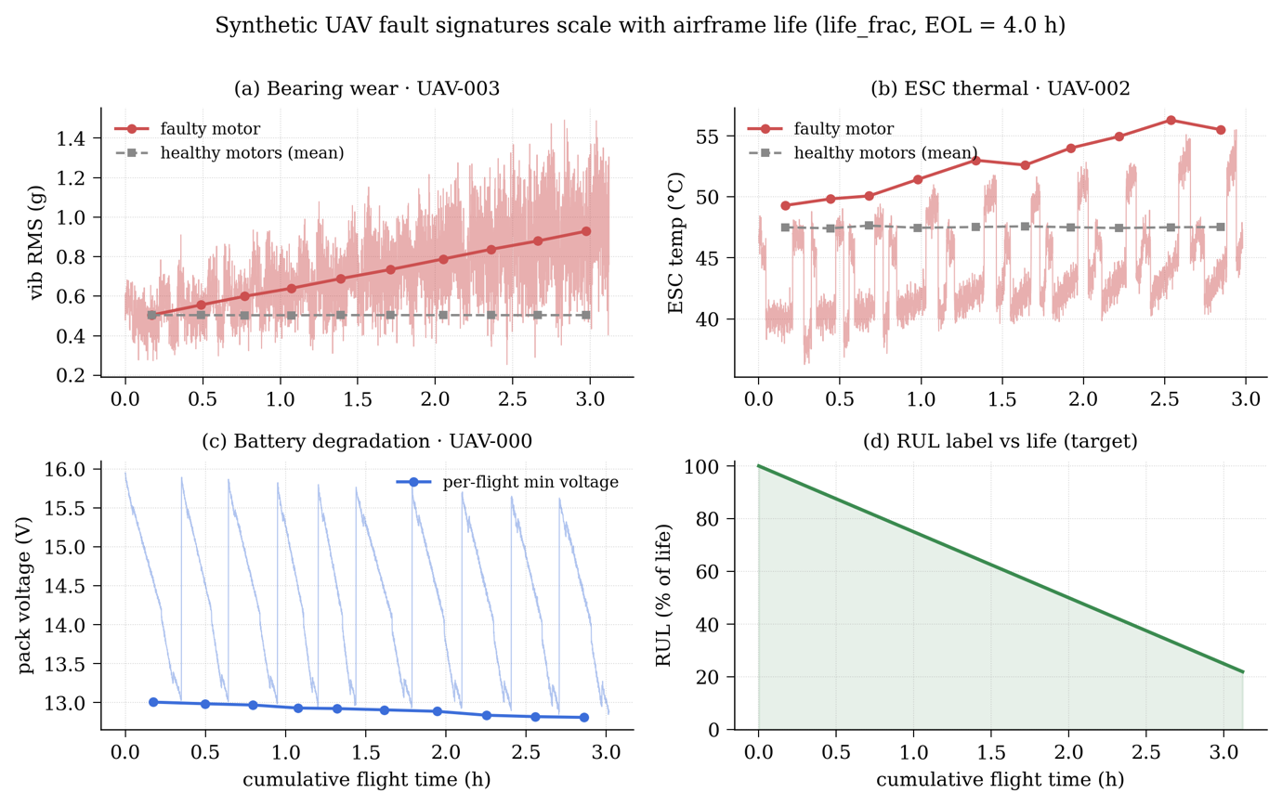
Figure 1:Synthetic UAV Fault Signatures

Reproducibility
The canonical train–test split provided with the C-MAPSS dataset is retained throughout all experiments. All sources of randomness are seeded as described previously to ensure reproducibility. For each run, the complete training history is serialized to artifacts/runs/<arch>_<dataset>/history.json, which serves as the data source for the training-curve panel displayed in the dashboard’s Lab view.

Model Architectures
All three architectures are implemented in PyTorch and follow a consistent interface. Each model accepts an input tensor of shape (batch, window, channels) and generates a scalar Remaining Useful Life (RUL) prediction for every input window. For the UAV variant, a shared encoder is coupled with an additional classification branch that simultaneously produces logits for four fault classes, allowing the model to perform fault classification and RUL estimation within a unified framework.

LSTM
The LSTM model (ml/models/lstm.py) comprises a two-layer stacked LSTM with hidden width 96 and inter-layer dropout 0.25. The final-timestep hidden state is fed to a regression head consisting of a linear layer projecting from 96 to 64 units, a ReLU activation, dropout, and a final linear projection to a one-dimensional output. The fault head, when active, is a single linear layer from the same 96-dimensional hidden state to four logits.

1D-CNN
The 1D-CNN model (ml/models/cnn.py) processes the input as a (channels × window) time-series signal. It consists of four convolutional blocks, each comprising a 1D convolution with 64 output channels and a kernel size of 5 using same padding, followed by batch normalization and a ReLU activation. These layers progressively extract temporal features while preserving the sequence length.
The final feature maps are aggregated using global average pooling across the time dimension, producing a 64-dimensional feature vector. Dropout is then applied for regularization before the features are passed to a regression head with the same output structure as the LSTM model. When fault classification is enabled, an additional fault head is included, consisting of a single linear layer operating on the 64-dimensional pooled representation.

Transformer Encoder
The Transformer architecture, implemented in ml/models/transformer.py, first projects the input features into a 96-dimensional latent representation using a linear embedding layer. A fixed sinusoidal positional encoding of the same dimensionality is then added to preserve temporal information across the input sequence. The encoded inputs are processed through two custom Transformer encoder layers.
Each encoder layer consists of a four-head multi-head self-attention mechanism, followed by a residual connection and Layer Normalization. The attention block is succeeded by a position-wise feed-forward network with a hidden dimension of 192 and GELU activation, which is again followed by a residual connection and Layer Normalization. Unlike the standard PyTorch implementation, the encoder layers are implemented in-house, enabling access to the post-softmax attention matrices from the final layer for explainability and interpretability analyses.
After the encoder stack, the sequence representations are aggregated using mean pooling across the temporal dimension. The resulting feature vector is passed through a regression head comprising Layer Normalization, a linear projection to 64 dimensions, GELU activation, dropout (0.2), and a final linear layer that produces a single continuous output value. Each encoder layer applies multi-head self-attention, where every timestep attends to all others through scaled dot-product attention:
$$Attention\left(Q,K,V\right)=softmax​\left(\frac{QK^{⊤}}{\sqrt{d_{k}}}\right)V$$
Equation 5: Scaled dot-product attention
with the h = 4 attention heads concatenated and linearly projected:
$$MHA\left(X\right)=\left[{head}_{1};…;{head}_{h}\right] W^{O}$$
Equation 6:Multi-head attention

Training Protocol
A single configuration-driven driver, ml/train.py, orchestrates training of all six models. The CLI takes a --dataset argument (CMAAPS or UAV) and an --arch argument (LSTM, CNN or transformer). Hyperparameters load from ml/config.py, which selects the device through a get_device() helper: it prefers Apple Silicon’s Metal Performance Shaders backend when available, falls back to CUDA on machines that have it, and to CPU otherwise.
The optimiser is AdamW with weight decay 1×10⁻⁴ and a learning rate of 1×10⁻³, on a cosine-annealing schedule over the full epoch budget. The regression loss is mean squared error. For the UAV variant the fault head is trained with cross-entropy, and the joint loss is the regression loss plus the classification loss weighted by 0.4. Training runs for forty epochs at batch size 512 on C-MAPSS, and thirty epochs at batch size 256 on the synthesised UAV fleet. Rather than applying explicit early stopping, the checkpoint with the lowest validation RMSE is retained for evaluation. Because the cosine schedule decays the learning rate to zero, validation RMSE improves almost monotonically, so in practice the retained checkpoint coincides with or falls within one to two epochs of the final epoch.
One practical issue is specific to the Transformer on Apple Silicon. Running a large validation set through the model in a single batch can exhaust the unified memory and trigger an MPS out-of-memory failure. Validation inference is therefore wrapped in a _batched_predict(model, X, batch=256) helper in ml/export.py, which streams windows through the model in fixed-size batches and concatenates the outputs. The same helper is used during the export step that bakes the per-asset payloads.
So, there’s this kind of unified training pipeline in ml/train.py that kind of orchestrates the model variants, you know through a configuration driven design pattern that’s not too complicated but still. The entry point takes in dataset and architecture stuff (like --dataset cmapss|uav and --arch lstm|cnn|transformer), while the hyper parameters and device selection get handed off to ml/config.py, kind of like it’s being delegated. For the device provisioning it’s adaptive, meaning get_device() goes first for Apple Silicon’s Metal Performance Shaders backend for native acceleration, then it backs off to CUDA when that’s available and finally it just defaults to CPU. This overall makes it portable across different development and compute setups, without you having to change the code each time.
The regression head is trained with mean squared error:
$$L_{reg}=\frac{1}{N}\sum_{i}{{\left({\overset{ˆ}{y}}_{i}-y_{i}\right)}^{2}}$$
Equation 7:Regression loss (MSE)
For the UAV multitask variant the fault head adds a cross-entropy term:
$$L_{cls}=-\frac{1}{N}\sum_{i}{\log{ }}softmax{\left(z_{i}\right)}_{c_{i}}$$
Equation 8: Fault loss (cross-entropy)
combined into a single objective with fault-loss weight λ = 0.4
$$L=L_{reg}+λ L_{cls}, λ=0.4$$
Equation 9: Combined objective (λ = 0.4)

Explainability Extraction

Attention
The in-house Transformer encoder layer returns the post-softmax attention matrix from each layer alongside its output (attn_w of shape (batch, window, window), with multi-head attention averaged across the head dimension at the call site). The attention matrix from the final encoder layer is captured at inference time, written into the per-asset JSON payload as the field attention_2d, and rendered by the dashboard’s Diagnostics view as a heatmap with axes labelled by relative timestep.
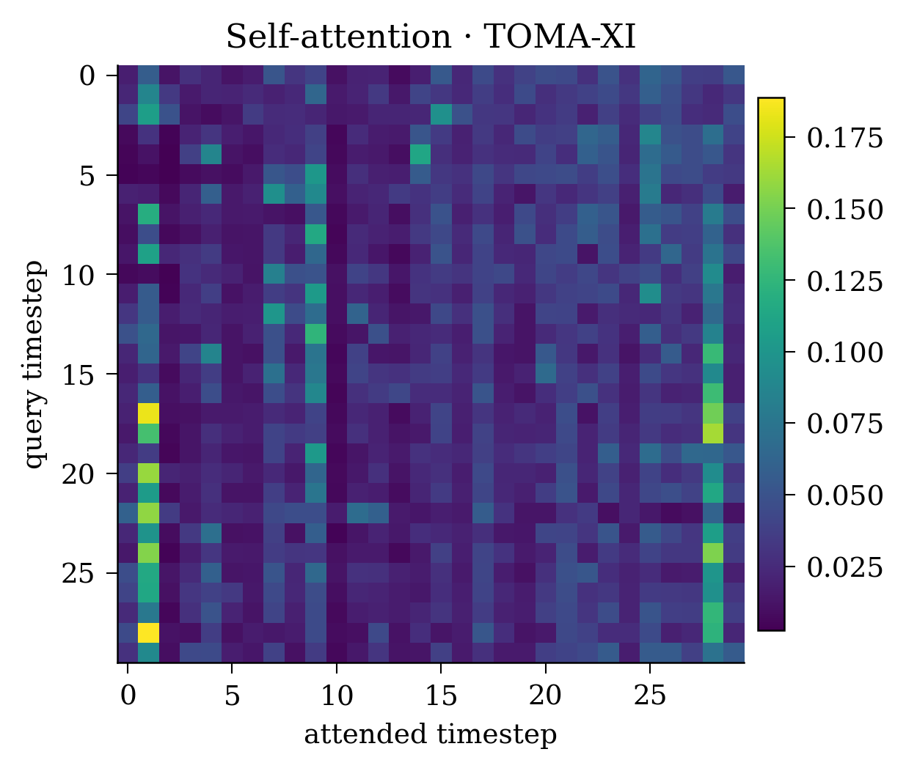
Figure 2: Transformer self-attention heatmap

Integrated Gradients
To improve the interpretability of the Transformer model, feature attributions were computed using the Integrated Gradients method implemented in the Captum library. The attributions were calculated with respect to the model's regression output, producing a tensor with dimensions corresponding to the input time window and sensor channels. To obtain an overall importance score for each sensor, the attribution values were aggregated across the temporal dimension by taking the mean of their absolute values, resulting in a single importance score per channel. These scores were subsequently normalised to facilitate comparison and visualisation. The resulting sensor importance values were stored in the sensor_importance field of the per-asset output, together with the corresponding sensor_names array. Within the dashboard's Diagnostics view, the sensor importance scores are presented as a horizontal bar chart, with the most influential sensor channel visually highlighted to aid interpretation of the model's predictions. Integrated Gradients attributes the predicted RUL to each input feature by integrating gradients along a straight path from a zero-baseline b to the input x:
$${IG}_{j}\left(x\right)=\left(x_{j}-b_{j}\right)\int_{0}^{1}{\frac{∂F​\left(b+α\left(x-b\right)\right)}{∂x_{j}}} dα, b=0$$
Equation 10:Integrated Gradients
Per-sensor importance is the time-averaged absolute attribution, normalised to [0,1] for the dashboard bar chart:
$$I_{f}=\frac{1}{T}\sum_{t}{\left|{IG}_{t,f}\right|}, {\overset{ˆ}{I}}_{f}=I_{f}/\max_{f}{I_{f}}$$
Equation 11:Sensor-importance reduction
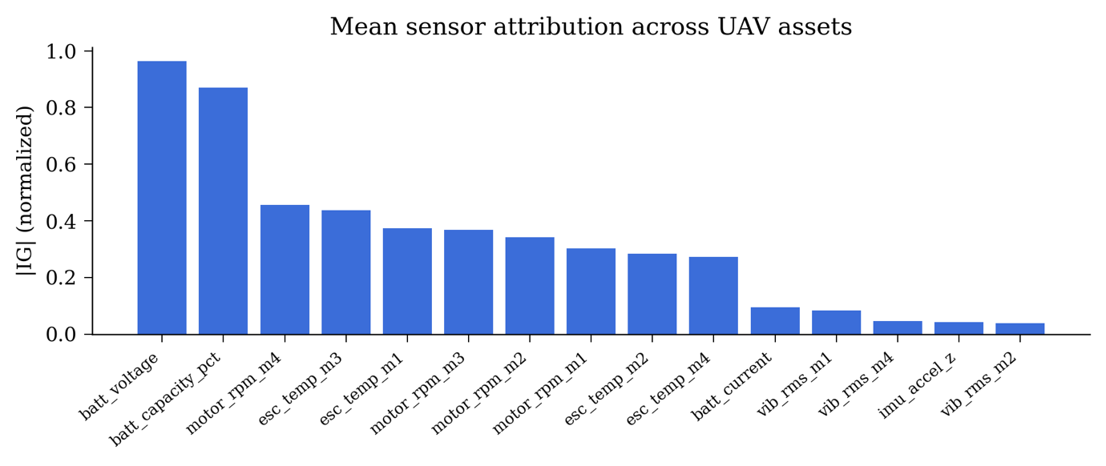
Figure 3: Mean sensor attribution across UAV assets

Live Inference Pipeline
Live inference is served by a FastAPI application defined in backend/main.py and run under uvicorn on port 8001. Three endpoints are exposed: GET /healthz returns service liveness; POST /predict accepts a single windowed input and returns a single prediction; and WS /stream serves a streaming session.
The streaming protocol is parameterised by query string: fault selects the fault class to inject, hours selects the simulated cumulative-flight-hours-into-life, seed selects the per-stream random seed, rate_hz selects the telemetry rate (default 10), and stride selects the prediction sub-rate (default 5, i.e. predict every fifth tick). On connection the server emits a single meta message describing the model architecture, device, and feature names, then a sequence of tick messages each containing the current sensor frame, and finally an end message at simulation termination. A prediction field is attached every stride-th tick once the rolling window buffer has accumulated enough history. The synthetic flight generator on the server side reuses the same procedural model as ml/data/uav_synth.py, ensuring that the live-inference distribution is consistent with the training distribution.
The optimization regime uses AdamW with L2 regularization (weight decay 1×10⁻⁴) and an initial learning rate of 1×10⁻³, plus cosine annealing across the whole training epoch budget. In practice, this ends up being a mostly monotonic decay down to 0 by the last epoch so you don’t really need early stopping rules, and the checkpoint with the lowest validation RMSE is retained as the evaluation artefact, which sits at or within one–two epochs of the final epoch. For regression tasks, the objective is mean squared error, and for the multitask UAV variant you apply cross entropy on the fault classification head, it’s weighted at 0.4, then mixed with the regression loss.
Training budgets sort of change depending on how complex the dataset feels: CMAPSS runs forty epochs with a batch size of 512, while the synthesized UAV fleet ends up at thirty epochs with batch size 256. Kinda, this captures dataset size and heterogeneity too, and you can say that the bigger batches help calm the gradient estimates on the more abundant CMAPSS samples.
The following computational constraint was the basis for the following architectural choice when making inferences using the Transformer model on Apple Silicon. Performing full-batch validation over a wide window of data leads to unified memory overflow resulting in MPS errors. It can be overcome using _batched_predict(model, X, batch=256) function in the ml/export.py module that performs inference in micro batches and then combines the results.

Evaluation Methodology
Quantitative evaluation reports per architecture, and per dataset too: RMSE (cycles for C-MAPSS, flight hours for UAV), the NASA Score for C-MAPSS, fault classification accuracy for the UAV variant total wall clock training time, and the number of training and validation windows. Also, per epoch validation RMSE is logged across the full forty or thirty epoch run, so it gives the training curve evidence that we show in Chapter 6.
Qualitative evaluation comprises three exhibits per asset, surfaced in the dashboard: the per-architecture predicted-RUL bar comparison against the true RUL in the Lab view; the attention heatmap in the Diagnostics view; and the sensor-importance bar chart in the Diagnostics view.
The quantitative evaluation assesses each model architecture on each dataset using several performance metrics. For the C-MAPSS dataset, model performance is measured using Root Mean Square Error (RMSE), expressed in cycles, and the NASA scoring function. For the UAV dataset, RMSE is reported in flight hours alongside fault-classification accuracy. In addition, the total training time and the number of training and validation windows are recorded for each experiment. To provide insight into the learning behaviour of the models, validation RMSE is tracked at every epoch throughout the full training process (40 epochs for C-MAPSS and 30 epochs for the UAV dataset). These results form the basis of the training-curve analysis presented in Chapter 6.
The qualitative evaluation focuses on the interpretability and visual assessment of model outputs through the dashboard interface. Three key visualisations are provided for each asset. First, the Lab view displays an overlay of the predicted Remaining Useful Life (RUL) trajectories from each architecture against the corresponding ground-truth RUL curve. Second, the Diagnostics view presents attention heatmaps, highlighting the time steps and sensor readings that most influenced model predictions. Finally, sensor-importance bar charts are used to illustrate the relative contribution of individual sensors to the model's decision-making process. Regression accuracy is reported as the root mean squared error between predicted and true RUL:
$$RMSE=\sqrt{\frac{1}{N}\sum_{i}{{\left({\overset{ˆ}{y}}_{i}-y_{i}\right)}^{2}}}$$
Equation 12: RMSE
For C-MAPSS we additionally report the asymmetric NASA score (d_i = ŷ_i − y_i), which penalises late predictions more heavily than early ones:
$$s_{i}=e^{-d_{i}/13}-1 \text{ if }d_{i}<0; s_{i}=e^{ d_{i}/10}-1 \text{ if }d_{i}≥0, Score=\sum_{i}{s_{i}}$$
Equation 13: NASA asymmetric score

System Design and Implementation
This chapter documents the implementation of ARES PdM as a software system. It complements the methodology chapter by setting out the architectural choices made in service of the research objectives, with particular attention to the contract between the machine-learning pipeline and the operator dashboard.
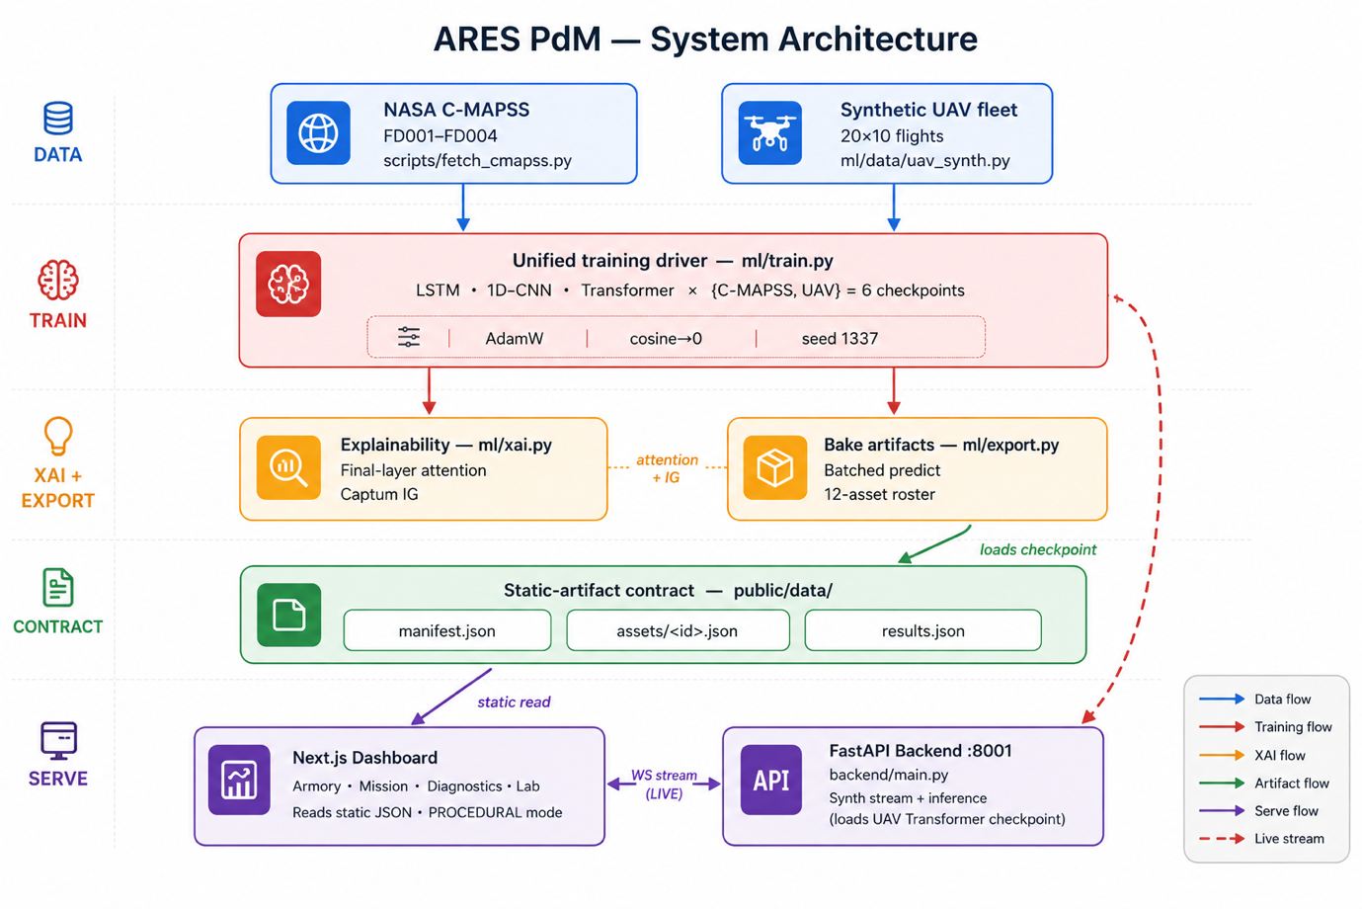
Figure 4: System Architecture
The following table shows the overall Architectural Summary

 | LSTM | 1D-CNN | Transformer
Core | 2-layer stacked LSTM | 4 conv blocks | 2 encoder layers
Width | hidden 96 | 64 channels | d_model 96
Kernel / heads / FFN | — | kernel 5 (same pad) | 4 heads | FFN 192 (GELU)
Temporal pooling | last hidden state | global average pool | mean over time
Dropout | 0.25 | 0.3 | 0.2
Regression head | 96->64->1 | 64->64->1 | LN->96->64->1
Fault head (UAV) | 96->4 | 64->4 | 96->4
Table 3:Architechture Summary

Repository Layout and Conventions
The project lives in a single repository with three main subtrees. The Python ML pipeline sits under ml/, the FastAPI inference backend under backend/, and the Next.js dashboard under app/, components/, and lib/. Public artifacts written by the ML pipeline and read by the dashboard go into public/data/, which is git-ignored. Trained checkpoints and per-run history go into artifacts/, also git-ignored. The point of this layout is that the repository can be cloned and reproduced from make phase1 without ever committing binary artifacts to version control.
A Makefile kind of lays out phase-level targets: make fetch to download C-MAPSS, make synth to re-generate the UAV fleet, make train to train all six models, make train-UAV for the UAV only subset, make export to bake the per asset payloads, make figures to regenerate the thesis figures, and make backend to launch the FastAPI server. A phase1 aggregator then runs the full pipeline from end to end. The dashboard development server is started with npm run dev, as well.

Static Artifact Contract
The single most consequential architectural decision in ARES PdM is the static-artifact contract between the ML pipeline and the dashboard. Three files are written by ml/export.py and read by the dashboard.
In public/data/manifest.json is stored the asset list (roster) consisting of arrays containing identifiers, names, classes (turbofans and quadrotors), current RUL, status enumeration (NOMINAL, WARNING, CRITICAL), and whether the asset is baked or live (data_source). This JSON file is loaded only once the app starts up through AppBootstrap.tsx which populates the Zustand store.
public/data/assets/.json is where the per-asset payload lives. It gets fetched on demand, when someone selects the asset or whatever. Inside there are six main, kind of important fields, like predictions_per_arch, a map from each architecture name to its single predicted RUL value for the asset (rendered as a grouped bar chart against the true RUL). For UAV assets this field is omitted, since a single served model produces the live prediction. Then rmse_per_arch, also a map from architecture name to a single RMSE number, not really a whole list. You also get sensor_names which is a string array that should be length F. There is sensor_window, shaped like (T, F) and it contains the most recent input window. Next comes attention_2d, a (T, T) matrix coming from the Transformer. After that, sensor_importance is a (F,) vector coming from Integrated Gradients. Finally, there’s an anomaly object that talks about the leading fault component, plus the severity and the timestamp, so you know when it happened and what mattered most.
public/data/results.json keeps the Model Lab payload, which is basically an array of training run objects. Inside there you’ll see the architecture name along with the dataset name, plus the headline metrics (rmse, score, fault_acc, epochs, train_size, test_size, seconds) and then, for each run there’s a per-epoch history array. That history tracks train loss, validation of RMSE, and the cosine-scheduled learning rate, every single epoch.
The contract has three properties that they kind of keep showing up as design patterns elsewhere in the system, you see. First its static: no server is needed for reading it. Second, it's complete: everything the dashboard renders for a given asset sits in one payload. Third, its symmetric, meaning the same field shapes get produced both by the offline export and by the live inference path. And that last part is really what allows the dashboard component layer to stay mode-agnostic, even when everything else changes.

The Dashboard
So, the dashboard is basically a Next.js 14 App Router thing, built on React 18 with TypeScript and Tailwind CSS, you know, that usual stack. For the three-dimensional rendering part it leans on @react-three/fiber, plus the drei helpers, and for charting it uses recharts. Client-side state is handled via zustand, not the server side, obviously. There are also four different views that are exposed, so you can switch between them.
The Armory view kind of is the fleet inventory. It uses a three-dimensional carousel to render procedural geometry for each of the twelve assets, eight turbofans and four quadrotors, all within one UAVModel.tsx component that branches on the asset class. There are no GLTF models being loaded, geometry is basically constructed on the fly from primitives. If you select an asset, you end up navigating to its diagnostic view.
The Mission view is basically the live operator HUD, it shows a radar panel, a telemetry panel, a health bar, and then a live chart too, plus there are controls to start, pause, and reset the whole mission. There’s a switch that flips between PROCEDURAL mode, which is like a heuristic flight envelope cooked up client-side by lib/telemetry.ts , so it doesn’t need the backend , and LIVE INFERENCE mode, which is a WebSocket subscription to the FastAPI backend, but that part is handled via lib/live.ts and lib/useLiveStream.ts, kind of mediated there. What’s a bit subtle is that the HUD component layer doesn’t really branch based on mode. The Zustand store, through its ingestLiveTick method, takes the raw WebSocket frames and translates them into the abstract TelemetryFrame shape that the panels read from, so all four panels behave the same whether you’re in PROCEDURAL mode or LIVE INFERENCE mode.
The Diagnostics view is this digital-twin inspection surface, kind of. A wireframe rendering of the selected asset (WireframeView.tsx) is sitting next to the Transformer’s attention matrix (AttentionHeatmap.tsx), along with the integrated Gradients sensor importance vector and a maintenance readout panel (MaintenanceReadout.tsx) that spits out a verbal summary about the predicted health state.
The Lab view is the academic-evaluation surface. A results table (ResultsTable.tsx) compares all six models on their respective datasets across RMSE, NASA Score (where applicable), classification accuracy (where applicable), training-set size, validation-set size, training time, and epochs. Training-loss and validation-RMSE curves are rendered per model from the history array of results.json by TrainingCurves.tsx. A per-asset prediction panel (PerAssetOverlay.tsx) lets the user select any asset and compare the trained architectures predicted RUL values against the true RUL as a grouped bar chart (all three architectures for C-MAPSS assets; the single served model for UAV assets).
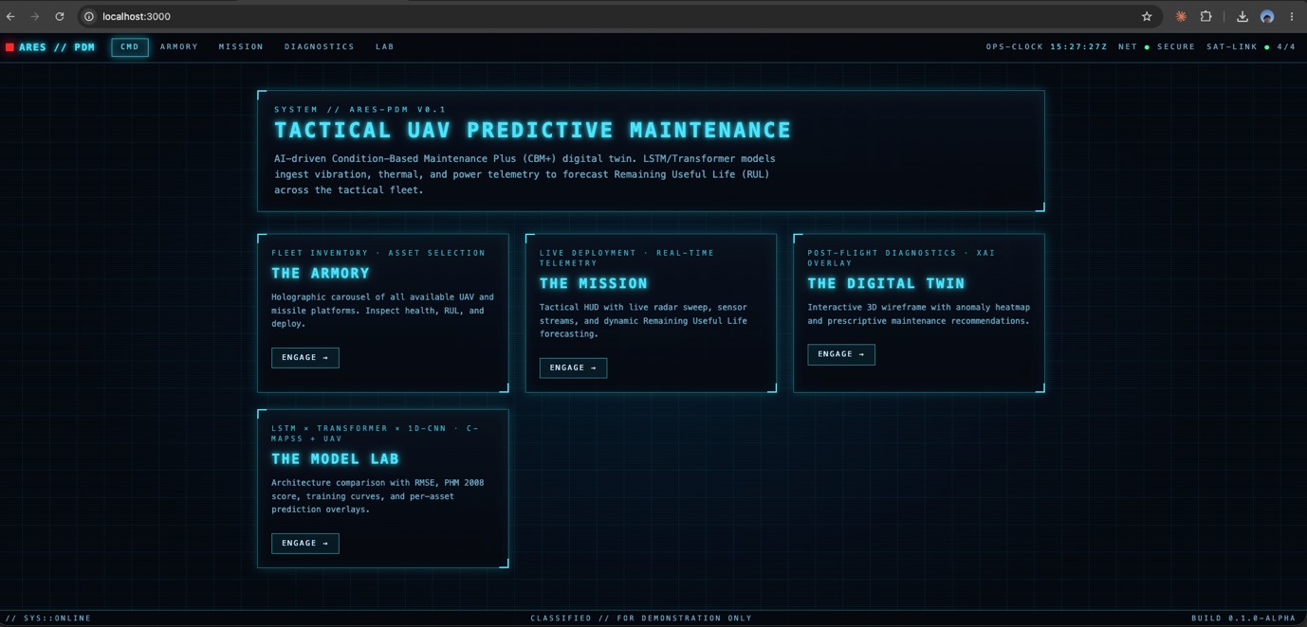
Figure 5: The Dashboard UI

The Inference Backend
The FastAPI backend is made of three Python modules, kind of simple. backend/inference.py loads the trained UAV Transformer checkpoint at process start and it exposes a thread-safe predict(window) function, that hands back a regression scalar plus a fault class probability vector. backend/synth_stream.py does the server-side flight generator and the rolling-window buffer, and it reuses the same procedural simulation as ml/data/uav_synth.py, so the live-inference distribution stays aligned with the training distribution or at least should. backend/main.py is the actual FastAPI application, defining the three endpoints that were mentioned in 4.5 and hooking the app’s startup event so it loads the model and prints arch, device, and len(feature_names) to the console.
The application runs under uvicorn on port 8001 chosen specifically to dodge the stale uvicorn instance that frequently occupies port 8000 on the development machine with the --reload flag during development.

The two modes of the Mission View
The Mission view mode switch is, honestly, the most operationally important piece of plumbing in the dashboard. PROCEDURAL mode exists because a demo can’t really assume the Python toolchain is installed on the demo machine, it generates a heuristic but plausible flight envelope client-side, and it runs through every panel and chart in the HUD with no backend at all. LIVE INFERENCE mode exists because a digital twin without a live data stream is not a true digital twin; it shows the actual outputs of the trained Transformer, and that becomes the HUD’s main content. The two modes end up being reconciled at the store layer, not the component layer, because that’s where ingestLiveTick comes in: it does a structural translation from the raw UAV channel layout into the abstract TelemetryFrame slots that the components already consume in PROCEDURAL mode. So, the panels end up rendering the same UI in both modes; the only real difference is where the numbers are coming from, and not so much how the screens behave.

Reproducibility and Deployment Notes
A new contributor should be able to reproduce the trained-model artifacts on Apple Silicon by cloning the repository, creating a Python 3.13 virtual environment, installing the pinned dependencies in requirements.txt, running make phase1, installing the Node dependencies with npm install, starting the dashboard with npm run dev, and, in a third shell, starting the backend with make backend. Two environmental quirks are documented in the project’s CLAUDE.md guide. Port 3000 is frequently occupied on the development machine, and Next.js auto-migrates to 3001 when it is; the backend is set to 8001 specifically to avoid the same collision on port 8000. And after re-training, the backend must be restarted (pkill -f "uvicorn backend.main" && make backend) to pick up the new checkpoints, because the model is loaded once at process start.
Two threshold-consistency points are also worth flagging. The rul_to_status mapping (with <35 CRITICAL and <65 WARNING in RUL units) deliberately lives in two places: server-side in ml/export.py, where it is applied at bake time, and client-side in lib/assets.ts, where it is re-applied when live RUL values arrive. The duplication is intentional, because the live re-classification path must not require a server round-trip. C-MAPSS RUL units are cycles, not percentages, and the dashboard accordingly clamps the roster bar’s display width to min (100, rul); conflating “RUL units” with “% of life” was an early source of UI confusion and is recorded in CLAUDE.md as understood.

Results and Evaluation
This chapter goes over the numerical and more descriptive outcomes from training and serving that six-model zoo in Chapter 4, but under the system that was laid out in Chapter 5. Everything is reported at seed 1 337, from one training-driver run only, so there is no ensemble stuff, nor per-subset tuning adjustments. Those alternative results would be higher anyway, but since they can vary with hyperparameters, they are not reported here.

Quantitative Results C-MAPSS
The combined test set across FD001–FD004 contains 707 engines, evaluated in the conventional way against the true RUL values supplied with the dataset. The combined sliding-window training set contains 125 819 windows. All three models are trained for forty epochs at batch size 512 with the cosine-annealed AdamW optimizer described in 4.3. The headline numbers are in Table 1.

Architecture | RMSE cycles | NASA Score | Train Times (s)
1D- CNN | 18.49 | 6515.8 | 87.6
LSTM | 16.47 | 4224.0 | 164.8
Transformer | 16.40 | 4073.9 | 41 3.8
Table 4: C-MAPSS Headline Results (combined test set, n=707)

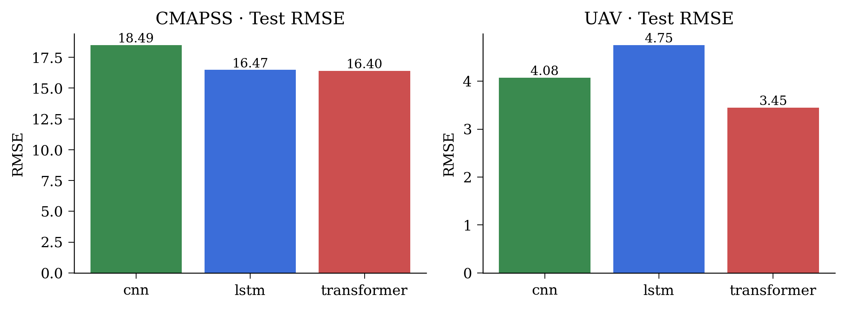
Figure 6: Results
The Transformer gets the smallest RMSE and the smallest NASA Score. The LSTM is kind of close right after on RMSE, but it falls off a bit more on the score, while the 1D-CNN lags on both. The spread in score between the 1D-CNN and those recurrent or attention-based setups is way bigger than the RMSE spread. This matches how the score has an asymmetric penalty: even if a model’s RMSE is only a few cycles higher, it can still end up with a meaningfully worse score when that extra mistake is bunched up on the late side of the real RUL. Also, the ordering during training time flips compared with the accuracy ordering the Transformer ends up taking about 4.7× longer to train than the 1D-CNN, which lines up with the quadratic burden of self-attention as the sequence length grows.
The Transformer's combined RMSE of 16.40 feels about right for the mid-tier kind of published results you see in single-seed, single-configuration C-MAPSS tests. Those frontier numbers that sit in the very-low-teens usually show up in papers that mix architectural tweaks with per-subset hyperparameter tuning, and sometimes also assembling, yeah. In this case, the work kind of skips both pieces, instead leaning on reproducibility under one single training driver.
The per-epoch validation RMSE trajectories, visualized in the dashboard's Lab view from the history field of results.json, show that all three models attain their lowest validation RMSE at or within one–two epochs of the final epoch under the cosine-annealing schedule, with no pronounced early plateau. These supports retaining the best-validation checkpoint rather than applying aggressive early stopping. The pattern is most evident for the Transformer, whose validation RMSE continues to decline, albeit gradually, through the final third of training consistent with the expectation that a higher-capacity model derives greater benefit from the full forty-epoch budget.
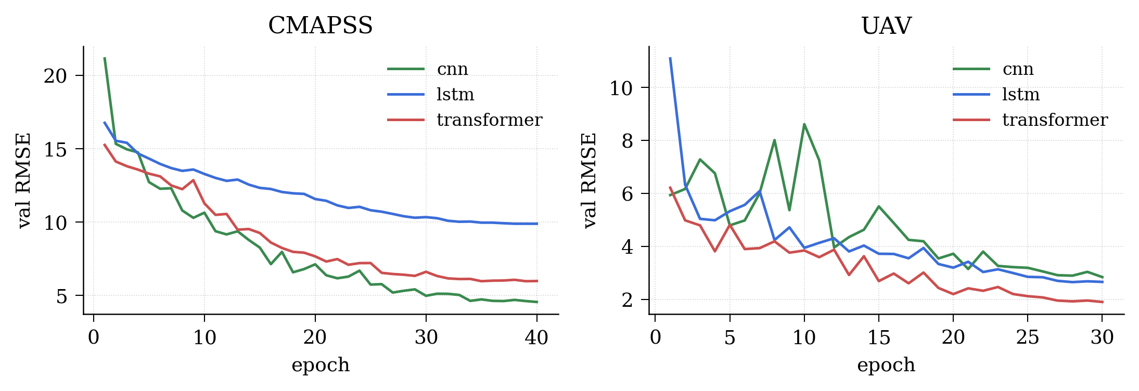
Figure 7: Loss Curves

Quantitative Results: Synthesized UAV Fleets
The synthesized UAV fleet of about twenty airframes run ten times each, at 10 Hz really gives 301 017 training windows and 85 292 validation windows after the stratified hold-out split shown in 4.1.2. From there, all three models get trained for thirty epochs, batch size 256, with the same optimizer and schedule. They all use a combined regression plus classification objective; the RMSE part is weighted at 1.0, and the cross-entropy fault part gets 0.4. The key figures sit in Table 2.

Architecture | RMSE (Flight-hours) | Fault Accuracy | Train Time (s)
1D – CNN | 4.08 | 0.615 | 321.2
LSTM | 4.75 | 0.880 | 514.9
Transformer | 3.45 | 0.955 | 1253.3
Table 5: Synthesized UAV Headline Results (Validation Set, n=85292 windows)

There are two interesting observations. First, the Transformer performs best among all models across both tasks, with a 15.4 % lower RMSE compared to the 1D-CNN, and a 34.0 percentage points higher fault accuracy. Second, the regression task accuracy of the 1D-CNN (RMSE of 4.08) exceeds that of the LSTM (RMSE of 4.75), while the 1D-CNN fault accuracy (61.5 %) lags behind that of the LSTM (88.0 %), lying somewhere between the purely random guessing baseline of 25 % on a four-way problem (although, again, this is not a balanced one) and the latter. It can be explained by the local convolutional architecture of the 1D-CNN being more adequate to learning of gradual degradation patterns, which characterize the regression target, whereas the separation of the four classes, three of which (bearing, ESC thermal and battery failure) are represented in different sensors, is harder.
Once again, the training-time ranking is reversed compared to the accuracy ranking, with the Transformer being approximately 3.9 times slower in training speed than the 1D-CNN model. The training time of the UAV Transformer, at around twenty-one minutes on the development machine (Apple Silicon with MPS), is reasonable enough.
On the UAV branch, the curves representing the per-epoch validation-RMSE of all three models have shown an improvement over the course of epochs using the cosine schedule, with the Transformer dropping below 2.0 RMSE in the later epochs, while the headline 3.45 figure represents the RMSE calculated using the out-of-sample validation windows, post all the training epochs (with a heavy contribution from the regression head).

The Two Datasets in Comparison
While the two datasets can be quantitatively compared using neither RMSE in cycles versus RMSE in flight hours nor NASA Score versus its UAV counterpart, the qualitative performance comparison between the three architectures on the two sets provides some insight into the relative power of the architectures. In the case of C-MAPSS, while the Transformer shows slight superiority to the LSTM in terms of RMSE (0.07 cycles), it clearly outperforms the other two models with respect to the NASA score. On the other hand, the gap in terms of RMSE between the Transformer and the other two models is greater in the UAV branch (1.30 and 0.63 flight hours with respect to LSTM and 1D-CNN respectively). What comes across from the analysis is that the differences in architecture play a more important role when the nature of the problem tackled by the model becomes more heterogeneous, like in the case of the UAV branch.

Qualitative Results Dashboard Surfaces
There are three qualitative outputs that are outputted from the dashboard for each individual asset. The first one is the attention matrix produced by the Transformer in its final layer which is visualized as a heatmap on the diagnostics view. The second one is the integrated gradients sensor importance vector which is visualized as a bar chart on the diagnostics view. The third is a per-architecture comparison of each model's predicted RUL against the true RUL, shown as a grouped bar chart in the Lab view's per-asset panel.
The intended assessment of these surfaces is operational, not statistical. That is, does the visualization allow an operator to query the predictive capability of the model in the event of a low RUL? My answer is that they do; however, at the time of writing, this is my own opinion. There have been no controlled operator studies done yet, so my assessment of the visualizations must be taken for what it is: a plausible clinical tool, not a clinically useful one. A controlled operator study is left for future work in 8.2.
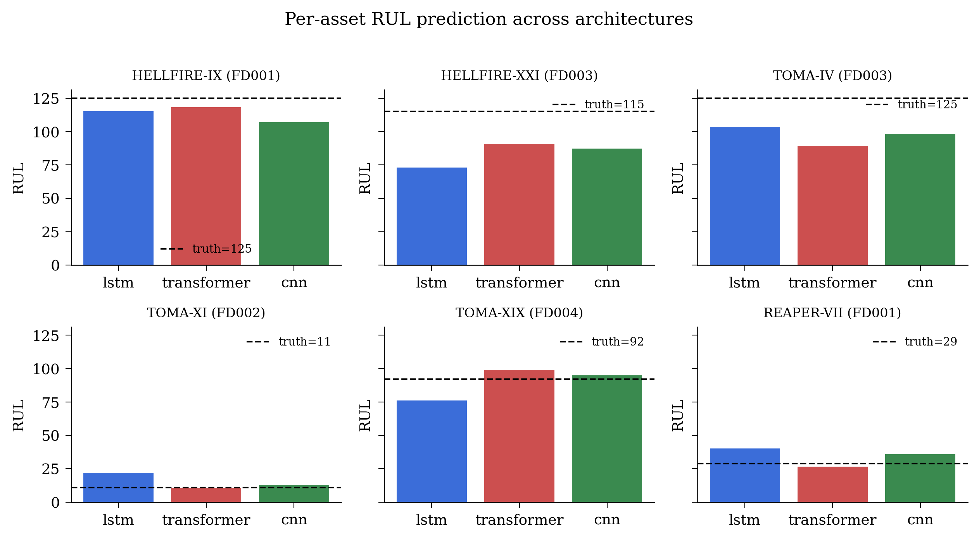
Figure 8: Qualitative Prediction across architectures

Live Inference
The prediction service implemented using the FastAPI backend makes its predictions available via the WebSocket protocol described in 4.5, where the generated telemetry is done at a rate of 10 Hz, while the Transformer performs an inference operation every fifth tick after filling up the rolling buffer. Qualitatively speaking, end-to-end live-inference functionality has been established through changing the Mission view's mode to LIVE INFERENCE from the default PROCEDURAL one. In that case, the telemetry and the health bar, as well as the live chart, are populated based on the WebSocket stream instead of being generated procedurally by the client.

Summary
The Transformer is the best-performing architecture in both tasks and metrics categories. It is slightly better than the other two architectures on C-MAPSS RMSE, decisively better on NASA Score, and decisively better on both the regression and classification tasks in the synthesized UAV challenge. The 1D-CNN network is the fastest training architecture and the best-performing non-attention architecture on the UAV regression task but the worst performer on the UAV classification task by a long way. The LSTM lies somewhere in-between on UAV classification and performs similarly to the Transformer on C-MAPSS RMSE but trains faster.

Discussion
In this chapter, we provide an operational context for the findings from Chapter 6. We examine why the Transformer model wins out, the sensitivity of the synthesized UAV performance to a key configuration constant, the boundaries within which the key performance measures can be transferred into the practical environment, and potential threats to validity.

Why the Transformer Wins
The Transformer’s lead over the LSTM and the 1D-CNN is consistent with the broader sequence-modelling literature, but the immediate explanation differs between the two datasets. On C-MAPSS the lead is small on RMSE (0.07 cycles over the LSTM) but larger on the NASA Score (150 score units over the LSTM, around 2 440 over the 1D-CNN). Because the score penalizes late predictions disproportionately, the score gap implies that the Transformer’s residuals fall less unfavorably on the late side than the LSTM’s, and that the 1D-CNN’s fall considerably more unfavorably on the late side than either. A natural reading is that the global-attention inductive bias lets the Transformer integrate evidence across the full thirty-cycle window when condition transitions or non-stationarities are present, whereas the 1D-CNN, with a finite receptive field built from four kernel-five layers, has a more local view and is more likely to overshoot on the late side when the recent window is misleading.
On the synthesized UAV fleet, the lead is kind of wider on both heads, and in my mind, it reads like a consequence of the joint regression- and classification objective, yeah. The 1D-CNN regression performance is competitive (4.08 RMSE vs the Transformer’s 3.45), but for classification it drops, sitting at 61.5% which is well behind the LSTM’s (88.0 %) and the Transformer’s (95.5%). The reading in 6.2 that the local-convolutional inductive bias fits gradual degradation but has trouble teasing apart fault signatures when they show up in different sensor channels matches the gap, and honestly is the single most plausible explanation I can offer. The Transformer’s advantage over the LSTM on the classification side (95.5% vs 88.0%) is also larger than on the regression side. That points to attention’s ability to pool information across the whole fifty-step window being especially useful for classification, where the evidence that matters may be concentrated in one or two timesteps inside the window, rather than being spread across it more evenly, as you might expect.
One further point: the training duration for the Transformer architecture is roughly 2.5x that of the LSTM on the C-MAPSS dataset and around 2.4x the LSTM’s on the UAVs. This improvement comes at a cost then, which would weigh heavily in the edge-computing scenario. As far as this experiment goes, the training of the models for deployment on FastAPI running locally on a developer machine training duration is not an issue.

The END_OF_THE_LIFE_HOURS Calibration
So, the synthesized fleet’s END_OF_LIFE_HOURS constant, which is currently 4.0, shows up in the project’s CLAUDE.md file as some sort of configuration, and the calibration of that thing was apparently the topic of a very explicit prior bug. In a previous build it was set to 200 hours, and honestly that kind of makes sense if you ignore how the math behaves. With ten flights, each roughly fifteen minutes, you only stack up around two and a half hours of life, so the RUL distribution got so tight. Like really narrow. Then a near-constant predictor sitting close to the upper bound could look competitive. In the end the regression basically collapsed into mean prediction, and any “advantage” an architecture had over a simple trivial baseline kind of vanished. Now, with the 4.0 value, the end-of-life life_frac lands near 0.75 by the final flight, and the RUL distribution across the fleet stretches to something like 25–100. That spread is broad enough that the regression stays non-trivial, instead of acting like it’s just guessing.
The calibration is genuine, but it is a genuine admission that the synthesis of UAV is configuration-dependent in a way that the C-MAPSS is not. C-MAPSS is locked down by NASA; the UAV synth is locked down by me. If a person redoes the calculations using their own END_OF_LIFE_HOURS value, they will find different headline numbers. This is the correct interpretation that the synthesized fleet proves the robustness of the pipeline in its ability to fit a meaningful regression on UAV-shaped data rather than being able to set up a meaningful absolute benchmark.

Generalization Gap
The C-MAPSS model performance figures of 16.40 combined RMSE are comparable to those of the midrange of the published literature, yet they fail to equal the very-low-teens range achieved by cutting-edge research combining architectural advancements with subset-wise hyperparameter optimization and ensembling techniques. In the current work, these two strategies were not adopted to achieve consistent reproducibility for a single training program and seed combination. An overzealous reader, if the headline figure refers to the architecture's theoretical maximum performance, might have misinterpreted its meaning.
The synthesized UAV results, with RMSE of 3.45 flight hours and fault accuracy of 95.5%, do not have direct relevance to any real tactical-class multirotor system due to the reasons outlined in 7.2. We synthesize the fleet of UAVs, inject four different fault signatures into the model with known parameters, and the resulting classification task is easier than a corresponding real-life problem involving fault signature interactivity and co-occurrence over time. What we should take away from the results of our experiments with UAV is that the pipeline can learn a non-trivial joint regression-and-classification task on the UAV-shaped dataset.

Operational Implications
If the framework were to be put into action on an actual fleet, three operational observations coming out of the current implementation would be expected to carry forward. First, the edge-served inference setup, with the FastAPI process sitting alongside the operator’s workstation, kind of matches what the digital-twin literature asks for, not really going with centralised cloud serving when it comes to real-time prognostics. Second, the static-artifact contract between the ML pipeline and the dashboard stays resilient if the backend has an outage: even when the live inference chain collapses, the dashboard still renders the most recent baked artifacts, and the asset’s status is appropriately stale flagged via the manifest’s data_source field. Third, the explainability layer attention maps alongside Integrated Gradients are a real substantive piece for operator trust. When an operator sees a low predicted RUL, they can dig into which timesteps, and which sensors, drove the prediction. That’s the operationally useful meaning of “explainable”, and it differs from the sense in which many PdM dashboards described in the published literature are, frankly, usually lacking.

Threats to Validity
Four threats to validity are explicitly acknowledged. First, the single-seed condition: results are reported at seed 1 337 only, and the variance across seeds is not characterised. A multi-seed evaluation would strengthen any claim about the architectural ranking, particularly the small RMSE gap between the LSTM and the Transformer on C-MAPSS, which is well within the typical seed-level variance in this literature. Second, the synthesised-fleet condition: as discussed in §7.3, the UAV results are conditional on a procedural model whose calibration is the author's. Third, the attention-as-explanation caveat: the literature on attention as a feature-importance proxy is mixed, and the framework's attention-based explanations should be understood as auditable traces of the model's processing rather than as causal accounts of the prediction. Fourth, the operator-evaluation gap: the dashboard has not been put in front of a working maintenance engineer for evaluation under a controlled task, and any claim about its operational utility is therefore a claim about its plausibility rather than its demonstrated utility.

Reflections on the Process
A kind of reflective note, on how the whole work got carried out, feels worth writing down. Honestly, the main methodological lesson, or I guess the single most consequential one, came rather late, during the practical phase, with the END_OF_LIFE_HOURS miscalibration that is laid out in 7.2. What matters here is mostly method, not the machinery itself: it is quite easy, while building a synthesised dataset, to slip in a parameter that makes the task so solvable it turns almost effortless, without that easiness being obvious in the headline metrics. For mitigation, which we kept in the final implementation, we chose to report outcomes on both the synthesised fleet and an external benchmark, namely C-MAPSS. In hindsight, if the external-benchmark numbers had degraded, that would probably have signalled the same sort of miscalibration earlier, before the project’s eventual discovery of it.
The second reflection is with respect to the static artifact contract presented in 5.2. The contract was initially used because the pragmatic need was felt to generate figures for the dissertation without having the running backend. With the passage of time, however, it served as the architectural foundation on which most decisions thereafter became easier thanks to this contract. In case the project is ever to be repeated, it will be designed earlier and with greater consideration in mind, and the path for live inference will be adapted to fit the contract rather than the other way around.

Conclusion and Future Work

Conclusion
ARES PdM was introduced in this thesis paper, which is an algorithmic framework based on digital twins for the purpose of performing predictive maintenance on tactical UAVs. In this algorithmic framework, three deep learning models - LSTM, 1D-CNN, and Transformer encoder were trained on two datasets including the C-MAPSS dataset, a dataset about turbofan engines, and another synthesized data set related to UAVs using a single training pipeline driven by configuration files. Predictive models are served by an operator dashboard that operates in offline replay and live inference modes.
The main benefit brought by this paper is that XAI techniques have been incorporated into the process of prediction for maintenance purposes directly. Instead of relying on an after-process evaluation for explainability, the attention maps and Integrated Gradients explanations are provided as part of the main visualization tools inside the operator’s dashboard. Another technical contribution of this architecture lies in the fact that static artifacts can be used to move from offline testing to live operation without any mode-specific modifications in the dashboard component itself.
Out of all the models considered in the study, the Transformer encoder performed the best for both data sets. For the C-MAPSS test set, it gave an RMSE of 16.40 and a NASA Score of 4,074. For the synthetic UAV test set, it delivered an RMSE of 3.45 for hours of flight prediction and an accuracy of 95.5% for fault classification. Although the results obtained from the C-MAPSS test set can be comparable with the findings in the mid-range predictive maintenance studies, they are certainly not state-of-the-art.
The outputs that result from explainability are effectively displayed on the dashboard for analysis by the operators of the factors affecting the predictive behavior of models. Nevertheless, the usability of the explanation itself has yet to be tested in any form of study to confirm its practical implications.
In response to the research question posed in Section 1.2, the findings indicate that a single, reproducible deep-learning pipeline can generate competitive Remaining Useful Life (RUL) predictions across both a widely used turbofan benchmark and a synthetic UAV fleet. Furthermore, the framework can provide interpretable explanations of these predictions through attention-based and gradient-based attribution methods at a level that appears suitable for operator decision support. Nevertheless, this conclusion should be considered considering several limitations, including the reliance on single-seed experiments, the use of a synthesised UAV dataset, and the absence of formal operator evaluation. These limitations are discussed in detail in Section 7.5.

Future Work
Four potential areas for future investigation can be easily drawn from both the limitations and the scope of the current research work. Firstly, a multi-seed approach could be used to improve the current analysis by calculating the average values and confidence intervals, thereby improving the reliability of our results about the ranking order of the different architectures that we have examined, especially considering the tightness of the results obtained in terms of RMSE metric using the C-MAPSS dataset.
Secondly, validation using a real fleet will enable the determination of external validity. Data from run-to-failure experiments on a tactical multirotor aircraft can be used to validate the pipeline without making any modifications to the architecture or methodology, thereby setting a benchmark under real operational conditions and adding to the existing findings from the synthesized fleet experiments.
Lastly, there is a need to systematically assess the deployment performance of the proposed framework. This involves conducting a series of benchmark experiments to measure the latency of WebSocket transmission, prediction throughput, and system responsiveness when subjected to different levels of computational load.
Finally, the effectiveness of the explainability layer could be investigated through a structured user study involving practising maintenance engineers. By assigning participants a defined diagnostic task and measuring decision quality, task completion time, and user confidence, such a study would provide empirical evidence regarding the extent to which the dashboard supports maintenance decision-making and operational workflows.
These extensions lie beyond the scope of the present dissertation but represent logical and valuable directions for subsequent investigation.

References
Al-Darraji, I., Derbali, M., Jerbi, H., Khan, F.Q., Jan, S., Piromalis, D. and Tsaramirsis, G. (2021) 'A technical framework for selection of autonomous UAV navigation technologies and sensors', Computers, Materials & Continua, 68(2), pp. 2771–2790. Available at: https://doi.org/10.32604/cmc.2021.017236 (Accessed: 3 June 2026).
Masalimov, K., Muslimov, T. and Munasypov, R. (2022) ‘Real-Time Monitoring of Parameters and Diagnostics of the Technical Condition of Small Unmanned Aerial Vehicle’s (UAV) Units Based on Deep BiGRU-CNN Models’, Drones, 6(11), p. 368. Available at: https://doi.org/10.3390/drones6110368
Costa, J., Farinha, J.T., Raposo, H., Marques Cardoso, A.J., Carmo, A., Gonçalves, P. and Farto, J. (2026) ‘A systematic literature review on AI-driven predictive maintenance and fault detection in aircraft systems’, Applied Sciences, 16(7), p. 3381. Available at: https://doi.org/10.3390/app16073381
Darrah, T., Frank, J., Quinones-Grueiro, M. and Biswas, G. (2021) “A Data Management Framework &amp; UAV Simulation Testbed for the Study of System-level Prognostics Technologies”, Annual Conference of the PHM Society, 13(1). doi: 10.36001/phmconf.2021.v13i1.3030.
Tang, X.; Wan, H.; Wang, W.; Gu, M.; Wang, L.; Gan, L. Lithium-Ion Battery Remaining Useful Life Prediction Based on Hybrid Model. Sustainability 2023, 15, 6261. https://doi.org/10.3390/su15076261
Heimes, F. O. (2008). Recurrent Neural Networks for Remaining Useful Life Estimation. International Conference on Prognostics and Health Management.
Hochreiter, S. and Schmidhuber, J. (1997) ‘Long Short-Term Memory’, Neural Computation, 9(8), pp. 1735–1780.
Kingma, D.P. and Ba, J., 2015. Adam: A method for stochastic optimization. In: International Conference on Learning Representations (ICLR).
Kokhlikyan, N., Miglani, V., Martin, M., Wang, E., Alsallakh, B., Reynolds, J., Melnikov, A., Kliushkina, N., Araya, C., Yan, S. and Reblitz-Richardson, O. (2020) Captum: A unified and generic model interpretability library for PyTorch. arXiv:2009.07896. Available at: https://arxiv.org/abs/2009.07896
Loshchilov, I. and Hutter, F., 2019. Decoupled weight decay regularization. In: International Conference on Learning Representations (ICLR 2019).
Loshchilov, I. and Hutter, F. (2017) SGDR: Stochastic Gradient Descent with Warm Restarts. Presented at the International Conference on Learning Representations (ICLR).
Murray, R.W. (2011) ‘Skillful Writing of an Awful Research Paper’, Analytical Chemistry, 83(3), p. 633.
Ozkat, E.C. et al. (Year) ‘Data-Driven Predictive Maintenance Model to Estimate RUL in a Multi-Rotor UAS’, International Journal of Micro Air Vehicles, volume(issue), pp. xx–xx
Paszke, A., Gross, S., Massa, F., Lerer, A., Bradbury, J., Chanan, G., Killeen, T., Lin, Z., Gimelshein, N., Antiga, L., Desmaison, A., Köpf, A., Yang, E., DeVito, Z., Raison, M., Tejani, A., Chilamkurthy, S., Steiner, B., Fang, L., Bai, J. and Chintala, S. (2019) 'PyTorch: An imperative style, high-performance deep learning library', in Wallach, H., Larochelle, H., Beygelzimer, A., d'Alché-Buc, F., Fox, E. and Garnett, R. (eds.) Advances in Neural Information Processing Systems, 32, pp. 8024–8035.
Sai, S., Garg, A., Jhawar, K., Chamola, V. and Sikdar, B. (2023) ‘A comprehensive survey on artificial intelligence for unmanned aerial vehicles’, IEEE Open Journal of Vehicular Technology, 4, pp. 713–738. doi:10.1109/OJVT.2023.3316181.
Saxena, A., Goebel, K., Simon, D. and Eklund, N. (2008) Damage propagation modeling for aircraft engine run-to-failure simulation. In: Proceedings of the International Conference on Prognostics and Health Management (PHM 2008). Denver, Colorado, USA, 6–9 October 2008.
Sundararajan, M., Taly, A. and Yan, Q. (2017) ‘Axiomatic Attribution for Deep Networks’, in Proceedings of the 34th International Conference on Machine Learning (ICML 2017).
Vaswani, A., Shazeer, N., Parmar, N., Uszkoreit, J., Jones, L., Gomez, A.N., Kaiser, Ł. and Polosukhin, I. (2017) ‘Attention Is All You Need’, Advances in Neural Information Processing Systems, 30.

Appendix

Appendix A - Reproductibility
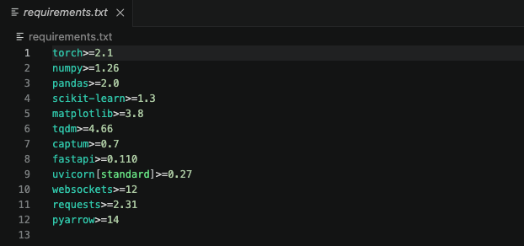
Appendix Figure 1: Python dependencies
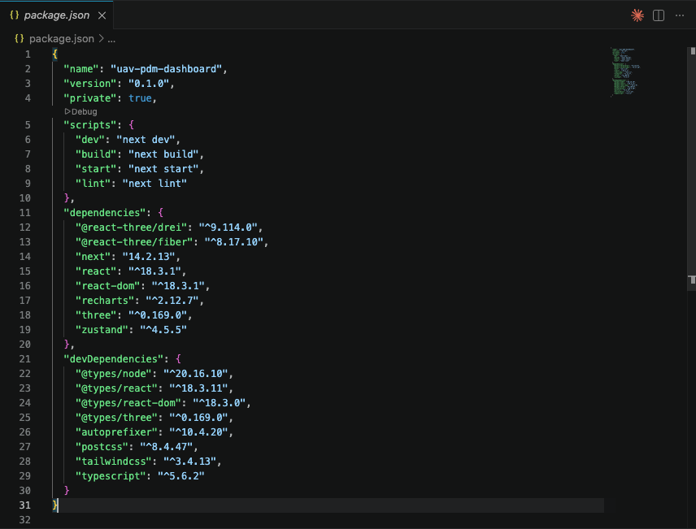
Appendix Figure 2: Frontend Dependencies

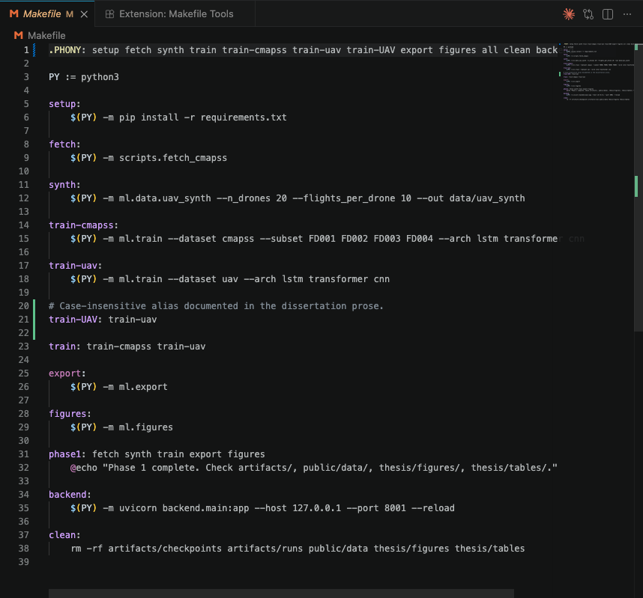
Appendix Figure 3: Environment Setup Targets
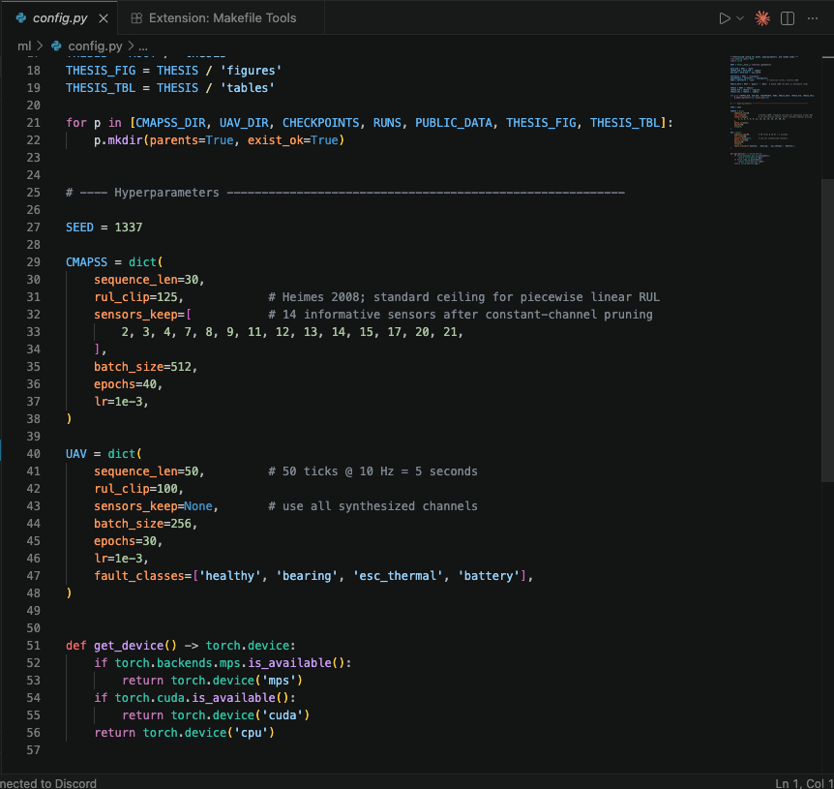
Appendix Figure 4: Central config and seed

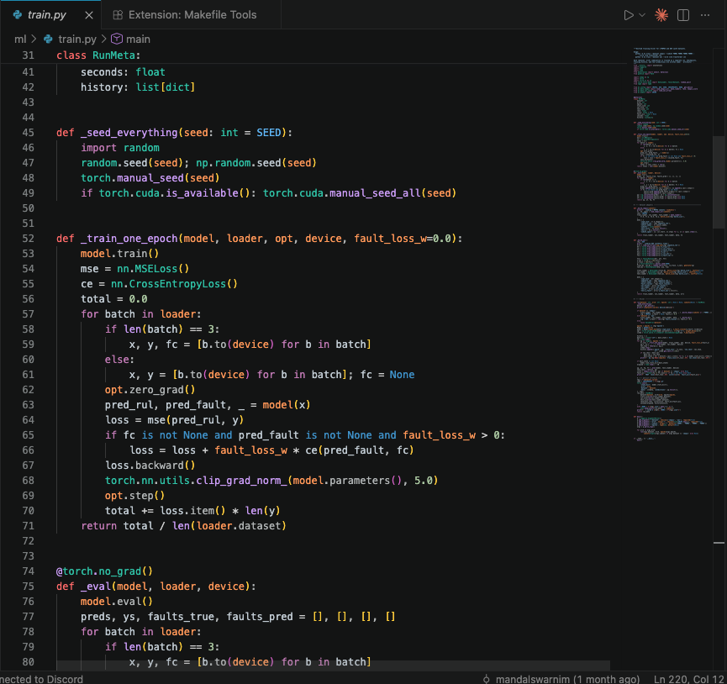
Appendix Figure 5: Training Seed

Appendix B – Core Code
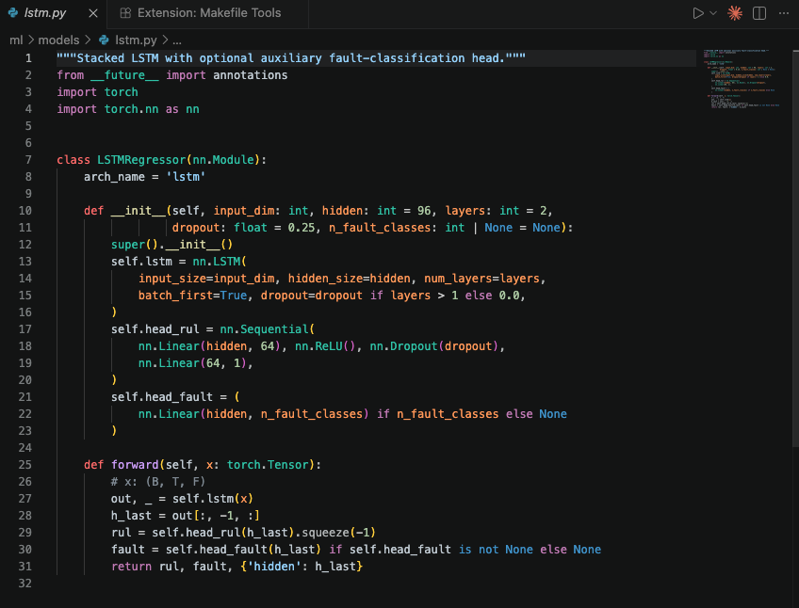
Appendix Figure 6: LSTM Model
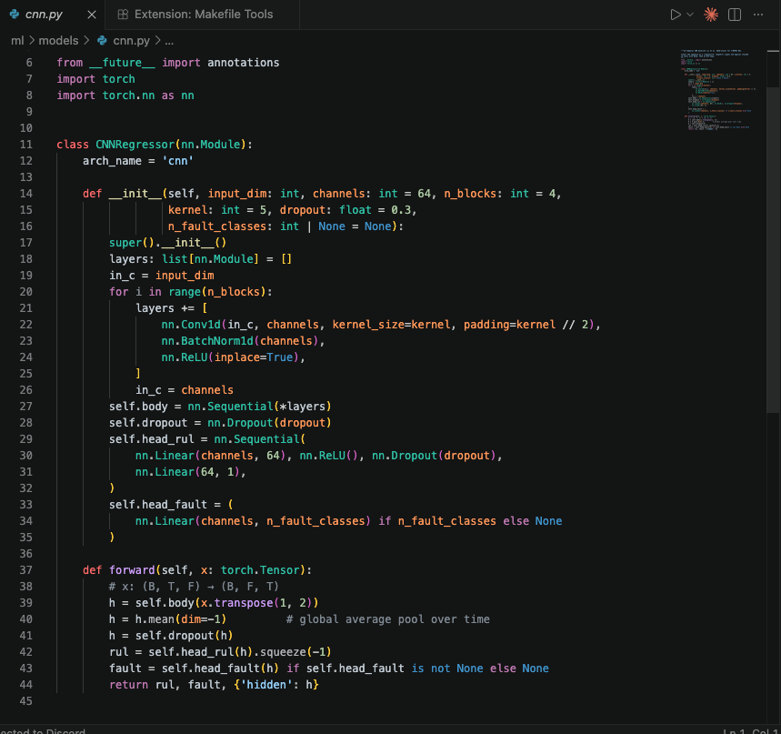
Appendix Figure 7: CNN Model
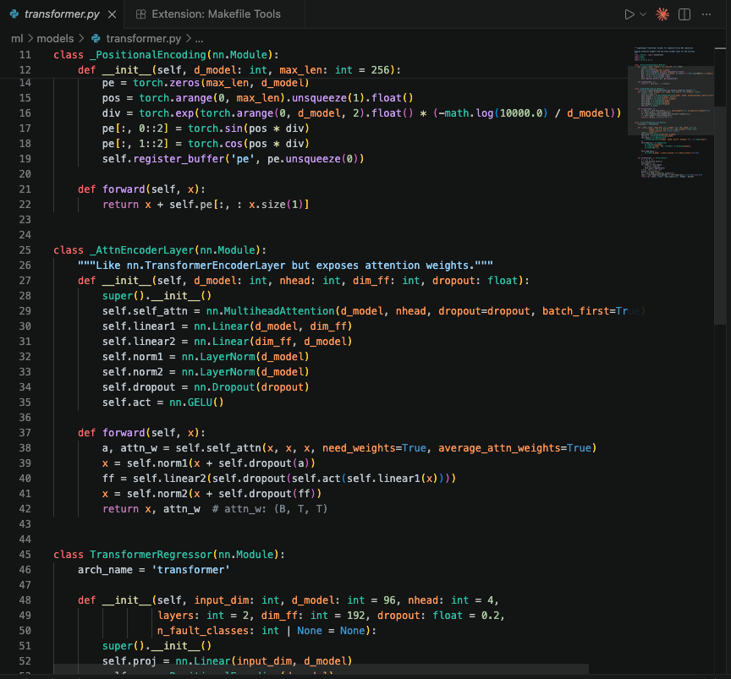
Appendix Figure 8: Transformer Model

Appendix C - Screenshots
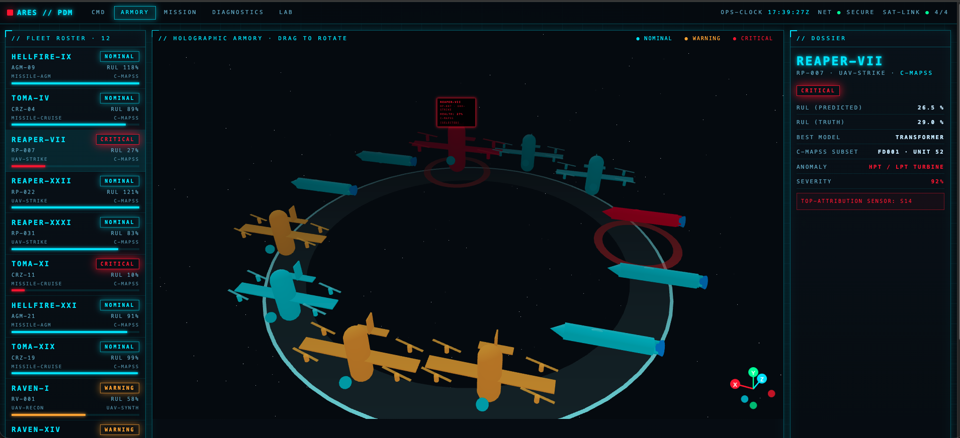
Appendix Figure 9:Armory Page

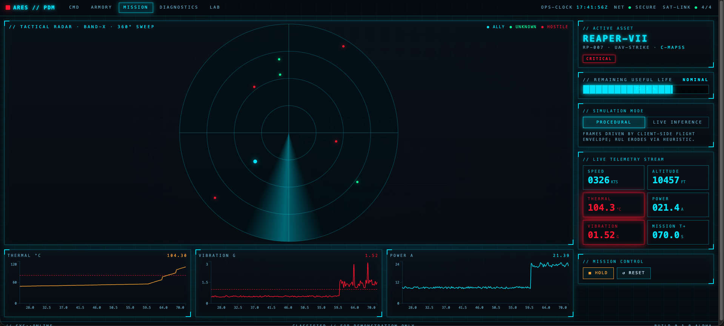
Appendix Figure 10: Mission Page
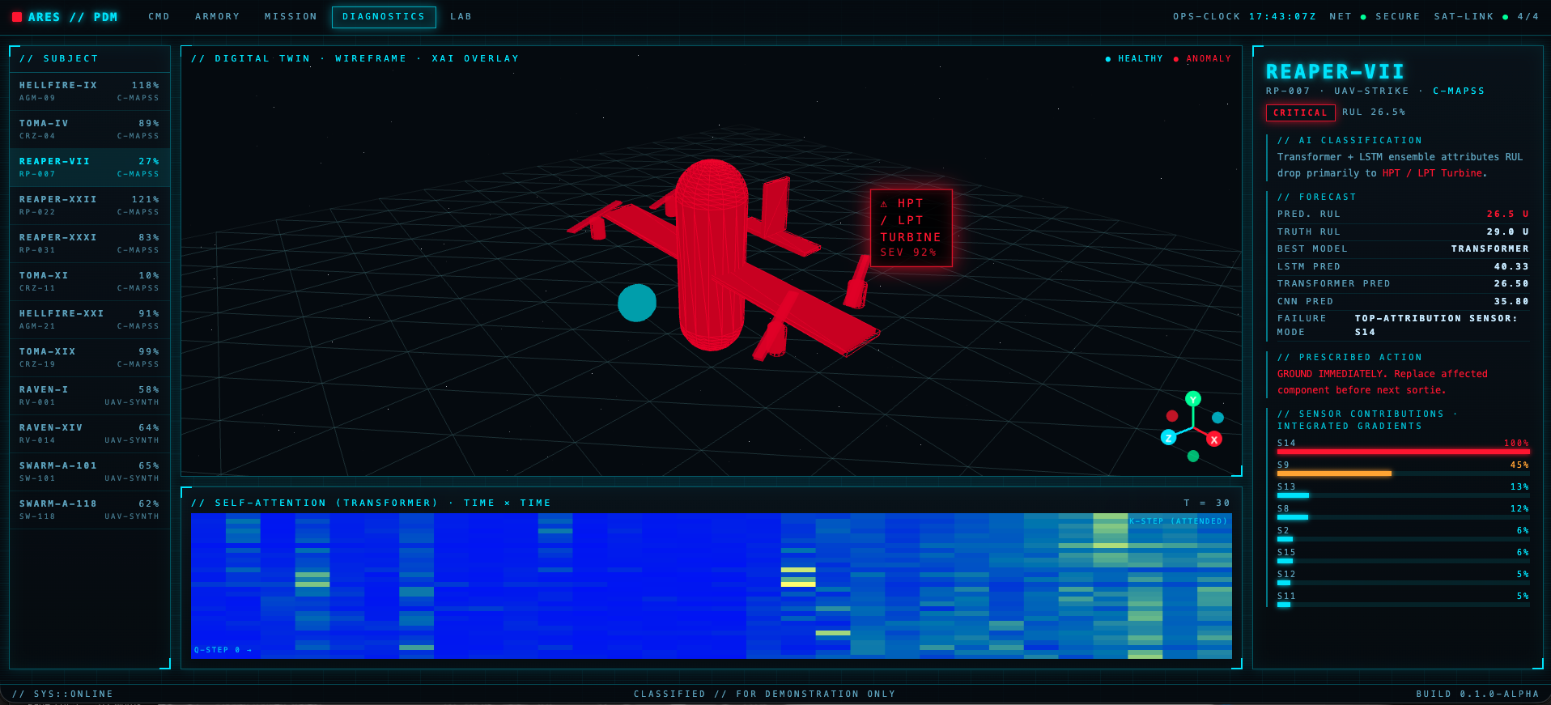
Appendix Figure 11: Diagnostics Page
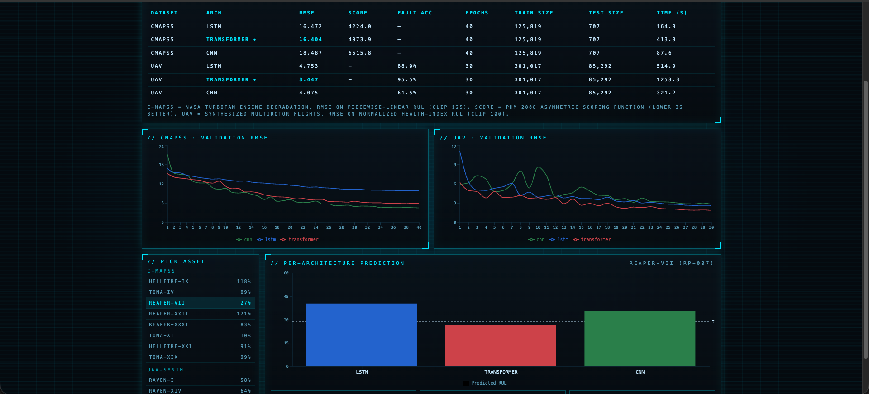
Appendix Figure 12: Lab Page

